**A**

**Project Report**

**on**

Deploying WebApp Using DevOps and AWS

**Submitted in partial fulfillment of the requirements**

**for the award of the degree of**

**Bachelor of Computer Applications**

**in**

**Cloud Technology & Information Security**

**by**

**Rahul**

**121520008**

**Under the Supervision of**

**Ms. Rani**



JAGAN NATH UNIVERSITY, BAHADURGARH

BAHADURGARH-JHAJJAR ROAD, HARYANA

|  |  |
| --- | --- |
| file-page1.jpg | JAGAN NATH UNIVERSITY, BAHADURGARH  BAHADURGARH-JHAJJAR ROAD, HARYANA |

# CERTIFICATE

This is to certify that the project report entitled “Deploying WebApp Using DevOps and AWS” submitted by Mr. Rahul **121520008** to the Jagan Nath University, Bahadurgarh Bahadurgarh-Jhajjar Road, Haryana in partial fulfillment for the award of Degree of Bachelor of Computer Applications in Cloud Technology & Information Security is a bona fide record of the project work carried out by them under my supervision during the year 2022-2023.

|  |  |
| --- | --- |
| **Ms. Rani**  Project Coordinator | **Dr Sahil Kansal**  **Mentor-IT Academics** |

**1**

|  |  |
| --- | --- |
| file-page1.jpg | JAGAN NATH UNIVERSITY, BAHADURGARH  BAHADURGARH-JHAJJAR ROAD, HARYANA |

# ACKNOWLEDGEMENT

We have taken efforts in this project. However, it would not have been possible without the kind support and help of many individuals and organizations. We would like to extend my sincere thanks to all of them.

We are highly indebted to Ms. Rani for her guidance and constant supervision. Also, we are highly thankful to them for providing necessary information regarding the project & also for their support in completing the project.

We are extremely indebted to Dr. Sahil Kansal, Department of Information Technology, and Ms. Rani, Project Coordinator, for their valuable suggestions and constant support throughout my project tenure. We would also like to express our sincere thanks to all faculty and staff members of Department for their support in completing this project on time.

We also express gratitude towards our parents for their kind co-operation and encouragement which helped me in completion of this project. Our thanks and appreciations also go to our friends in developing the project and all the people who have willingly helped me out with their abilities.

Rahul

# ABSTRACT

We have proposed an approach for building extraction from very high resolution (VHR) multispectral images using NDVI (Normalized Difference Vegetation Index) based segmentation and morphological operations. This approach uses both spatial and spectral properties of an image scene for building detection. Spectral properties are related to NDVI based segmentation and spatial properties are related to the morphological operations. Normally an image scene is consists of natural region (vegetation and soil) and manmade regions (buildings and roads). Use of NDVI (spectral properties) eliminates the chance of shadow being a building region and other similar regions that are not road like soil, vegetation etc. because shadow is a spatial property and NDVI is based on spectral property irrespective of brightness in the image. By using NDVI we can eliminate the natural regions from the man made.

**CONTENTS**

**Title**

**CERTIFICATE 1**

**ACKNOWLEDGEMENT 2**

**ABSTRACT 3**

**CONTENTS 4**

**CHAPTER 1: INTRODUCTION 5-7**

1.1 What is DevOps?

1.2 Advantages

1.3 Why to use DevOps?

**CHAPTER 2: LITERATURE REVIEW 8-10**

2.1 History

2.2 Methods

**CHAPTER 3: CI AND CD PIPELINE 11-14**

3.1 CI

3.2 CD

3.3 Tools

**CHAPTER 4: IMPLEMENTATION 15-40**

**CHAPTER 5: RESULT AND OUTPUT 41**

**CHAPTER 6: CONCLUSION 42**

Chapter 1

Introduction

* 1. What is DevOps?

DevOps can be best explained as people working together to conceive, build and deliver secure software at top speed. DevOps practices enable software development (dev) and operations (ops) teams to accelerate delivery through automation, collaboration, fast feedback, and iterative improvement.

Stemming to software development, a DevOps process expands on the cross-functional approach of building and shipping applications in a faster and more iterative manner. In adopting a DevOps development process, you are making a decision to improve the flow and value delivery of your application by encouraging a more collaborative environment at all stages of the development cycle.

DevOps represents a change in mindset for IT culture. In building on top of Agile, lean practices, and systems theory, DevOps focuses on incremental development and rapid delivery of software. Success relies on the ability to create a culture of accountability, improved collaboration, empathy, and joint responsibility for business outcomes.

* 1. Who is DevOps Engineer?

DevOps engineers reduce that complexity, closing the gap between actions needed to quickly change an application, and the tasks that maintain its reliability.

Development teams and IT operations teams can have different skills and different goals. Developers want to introduce new features to an application, while operations teams want to preserve the stability of an application once it is released.

DevOps is all about the unification and automation of processes, and DevOps engineers are instrumental in combining code, application maintenance, and application management. All of these tasks rely on understanding not only development life cycles, but DevOps culture, and its philosophy, practices, and tools.

Within an agile environment, developers, system administrators, and programmers can be siloed, working on the same product but not sharing information necessary to ensure value to the user.

Some organizations may hire professionals to "perform DevOps" within their workflows, but because successful DevOps adoption depends on changes to culture and process, this may just deepen the disconnect between developers and operational teams.

* 1. Advantages
* 1 Faster and more frequent delivery of updates and features will not only satisfy the customers but will also help your company take a firm stand in a competitive market.
* Do you know that the tension involved in the release of new features and fixes or updates can topple the stability of your workspace and decreases the overall productivity? Improve your work environment with a steady and well-balanced approach of operation with DevOps practice.
* Collaboration between development and operation teams and frequent capturing of user feedback leads to a significant improvement in the quality of the product.
* DevOps has greater benefits when compared to the traditional model as it helps in detecting and correcting problems quickly and efficiently. As the flaws are repeatedly tested through automation, the team gets more time in framing new ideas.
* It’s no secret that making your business agile can help you to stay ahead in the market. Thanks to DevOps, it is now possible to obtain the scalability required to transform the business.
* In DevOps methodology, all of the departments are responsible for maintaining stability and offering new features. Therefore, the speed of software delivery is fast and undisturbed, unlike the traditional method.
* Ensuring quick and stable solution to technical errors in software management is one of the primary benefits of DevOps.
* With the elimination of silo and promotion of collaboration, this process allows for easy communication among the team members, making them more focused in their specialised field. Therefore, incorporating DevOps practises has also led to an upsurge in productivity and efficiency among the employees of a company.
* With proper collaboration, DevOps helps in cutting down the management and production costs of your departments, as both maintenance and new updates are brought under a broader single umbrella.

## DevOps toolchain

Followers of DevOps practices often use certain DevOps-friendly tools as part of their DevOps “toolchain.” The goal of these tools is to further streamline, shorten, and automate the various stages of the software delivery workflow (or “pipeline”). Many such tools also promote core DevOps tenets of automation, collaboration, and integration between development and operations teams. The following shows a sample of tools used at various DevOps lifecycle stages.

* **Plan.** This phase helps define business value and requirements. Sample tools include Jira or Git to help track known issues and perform project management.
* **Code.** This phase involves software design and the creation of software code. Sample tools include GitHub, GitLab, Bitbucket, or Stash.
* **Build.** In this phase, you manage software builds and versions, and use automated tools to help compile and package code for future release to production. You use source [code repositories](https://www.netapp.com/devops-solutions/code-artifact-repository) or package repositories that also “package” infrastructure needed for product release. Sample tools include Docker, Ansible, Puppet, Chef, Gradle, Maven, or JFrog Artifactory.
* **Test.** This phase involves continuous testing (manual or automated) to ensure optimal code quality. Sample tools include JUnit, Codeception, Selenium, Vagrant, TestNG, or BlazeMeter.
* **Deploy.** This phase can include tools that help manage, coordinate, schedule, and automate product releases into production. Sample tools include Puppet, Chef, Ansible, Jenkins, Kubernetes, OpenShift, OpenStack, Docker, or Jira.
* **Operate.** This phase manages software during production. Sample tools include Ansible, Puppet, PowerShell, Chef, Salt, or Otter.
* **Monitor.** This phase involves identifying and collecting information about issues from a specific software release in production. Sample tools include New Relic, Datadog, Grafana, Wireshark, Splunk, Nagios, or Slack.

Chapter 2

History of DevOps

2.1 The DevOps movement started to coalesce sometime between 2007 and 2008, when IT operations and software development communities raised concerns what they felt was a fatal level of dysfunction in the industry.

They railed against the traditional software development model, which called for those who write code to be organizationally and functionally apart from those who deploy and support that code.

Developers and IT had separate (and often competing) objectives, separate department leadership, separate key performance indicators by which they were judged, and often worked on separate floors or even separate buildings. The result was siloed teams concerned only with their own fiefdoms, long hours, botched releases, and unhappy customers. Surely there’s a better way, they said. So, the two communities came together and started talking – with people like Patrick Debois, Gene Kim, and John Willis driving the conversation.

What began in online forums and local meet-ups is now a major theme in the software zeitgeist, which is probably what brought you here! You and your team are feeling the pain caused by siloed teams and broken lines of communication within your company.

You’re using but still struggling to get that code out the door without a bunch of drama. You’ve probably heard a few things about DevOps and the seemingly magical effect it can have on teams: Nearly all (99%) of DevOps teams are confident about the success of their code that goes into production, in a survey of 500 DevOps practitioners conducted by Atlassian¹.

However, DevOps isn’t magic, and transformations don’t happen overnight. The good news is that you don’t have to wait for upper management to roll out a large-scale initiative. By understanding the value of DevOps and making small, incremental changes, your team can embark on the DevOps journey right away.

* 1. Types of Methodology

## Agile development methodology **-** Teams use the agile development methodology to minimize risk (such as bugs, cost overruns, and changing requirements) when adding new functionality. In all agile methods, teams develop the software in iterations that contain mini-increments of the new functionality. There are many different forms of the agile development method, including scrum, crystal, extreme programming (XP), and feature-driven development (FDD).

* **Pros:** The primary benefit of agile software development is that it allows software to be released in iterations. Iterative releases improve efficiency by allowing teams to find and fix defects and align expectation early on. They also allow users to realize software benefits earlier, with frequent incremental improvements.
* **Cons:** Agile development methods rely on real-time communication, so new users often lack the documentation they need to get up to speed. They require a huge time commitment from users and are labor intensive because developers must fully complete each feature within each iteration for user approval.
* DevOps deployment methodology - [DevOps](https://www.synopsys.com/glossary/what-is-devops.html) is not just a development methodology but also a set of practices that supports an organizational culture. DevOps deployment centers on organizational change that enhances collaboration between the departments responsible for different segments of the development life cycle, such as development, quality assurance, and operations.
* **Pros:** DevOps is focused on improving time to market, lowering the failure rate of new releases, shortening the lead time between fixes, and minimizing disruption while maximizing reliability. To achieve this, DevOps organizations aim to automate [continuous deployment](https://www.synopsys.com/glossary/what-is-continuous-deployment.html) to ensure everything happens smoothly and reliably. Companies that use DevOps methods benefit by significantly reducing time to market and improving customer satisfaction, product quality, and employee productivity and efficiency.
* **Cons:**Even in light of its benefits, there are a few drawbacks to DevOps:
* Some customers don’t want continuous updates to their systems.
* Some industries have regulations that require extensive testing before a project can move to the operations phase.
* If different departments use different environments, undetected issues can slip into production.
* Some quality attributes require human interaction, which slows down the delivery pipeline.

## Waterfall development method - Many consider the waterfall method to be the most traditional software development method. The waterfall method is a rigid linear model that consists of sequential phases (requirements, design, implementation, verification, maintenance) focusing on distinct goals. Each phase must be 100% complete before the next phase can start. There’s usually no process for going back to modify the project or direction.

## **Pros:** The linear nature of the waterfall development method makes it easy to understand and manage. Projects with clear objectives and stable requirements can best use the waterfall method. Less experienced project managers and project teams, as well as teams whose composition changes frequently, may benefit the most from using the waterfall development methodology.

## **Cons:** The waterfall development method is often slow and costly due to its rigid structure and tight controls. These drawbacks can lead waterfall method users to explore other software development methodologies.

## Rapid application development **-** Rapid application development (RAD) is a condensed development process that produces a high-quality system with low investment costs. Scott Stiner, CEO and president of UM Technologies, [said in Forbes](http://www.forbes.com/sites/forbestechcouncil/2016/08/24/rapid-application-development-rad-a-smart-quick-and-valuable-process-for-software-developers/), “This RAD process allows our developers to quickly adjust to shifting requirements in a fast-paced and constantly changing market.” The ability to quickly adjust is what allows such a low investment cost. The rapid application development method contains four phases: requirements planning, user design, construction, and cutover. The user design and construction phases repeat until the user confirms that the product meets all requirements.

## Chapter 3

## CI And CD Pipeline

## 3.1 Continuous integration

## In modern application development, the goal is to have multiple developers working simultaneously on different features of the same app. However, if an organization is set up to merge all branching source code together on one day (known as “merge day”), the resulting work can be tedious, manual, and time-intensive. That’s because when a developer working in isolation makes a change to an application, there’s a chance it will conflict with different changes being simultaneously made by other developers. This problem can be further compounded if each developer has customized their own local [integrated development environment (IDE)](https://www.redhat.com/en/topics/middleware/what-is-ide?cicd=32h281b), rather than the team agreeing on one [cloud](https://www.redhat.com/en/topics/cloud?cicd=32h281b)-based IDE.

Continuous integration (CI) helps developers merge their code changes back to a shared branch, or “trunk,” more frequently—sometimes even daily. Once a developer’s changes to an application are merged, those changes are validated by automatically building the application and running different levels of automated testing, typically unit and integration tests, to ensure the changes haven’t broken the app. This means testing everything from classes and function to the different modules that comprise the entire app. If automated testing discovers a conflict between new and existing code, CI makes it easier to fix those bugs quickly and often.

## 3.2 Continuous delivery

Following the automation of builds and unit and integration testing in CI, continuous delivery automates the release of that validated code to a repository. So, in order to have an effective continuous delivery process, it’s important that CI is already built into your development pipeline. The goal of continuous delivery is to have a codebase that is always ready for deployment to a production environment.

In continuous delivery, every stage—from the merger of code changes to the delivery of production-ready builds—involves test automation and code release automation. At the end of that process, the operations team is able to deploy an app to production quickly and easily.

This makes it much easier to continuously receive and incorporate user feedback. Taken together, all of these connected CI/CD practices make deployment of an application less risky, whereby it’s easier to release changes to apps in small pieces, rather than all at once. There’s also a lot of upfront investment, though, since automated tests will need to be written to accommodate a variety of testing and release stages in the CI/CD pipeline.

3.3 Tools

GitHub - is a for-profit company that offers a cloud-based repository service called Git. It was designed to make it easy for individuals and organizations to use Git for collaboration and version control. Since it is the largest community of developers in the world, putting a code or a project into GitHub means more reach and exposure.

Programmers can pick source codes in many different languages and use Git, the command-line interface, to make and keep track of any changes. As a result, every team member receives help to work together on multiple projects from any location, thanks to top-notch collaboration. As a token of its flexibility, GitHub lets users review previous projects created at an earlier point in time.

With the meaning of GitHub explained and out of the way, you can’t help but wonder why it is so important to developers. Firstly, GitHub offers a unique, user-friendly interface that allows a novice coder to take advantage of Git. That’s great since, without GitHub, it would take more technical knowledge and use of the command line.

GitHub’s interface is easy enough to help individuals manage other projects, such as journals. Also, anybody can sign up and [host a GitHub](https://everhour.com/blog/how-to-host-website-on-github/) public code repository at no cost. That is why GitHub is especially popular with open-source projects. Further, GitHub helps organizations manage team members and security and develop internal projects.

Docker - is an open source platform that enables developers to build, deploy, run, update and manage containers—standardized, executable components that combine application source code with the operating system (OS) libraries and dependencies required to run that code in any environment.

[Containers](https://www.ibm.com/topics/containers) simplify development and delivery of distributed applications. They have become increasingly popular as organizations shift to [cloud-native](https://www.ibm.com/topics/cloud-native) development and hybrid [multi cloud](https://www.ibm.com/topics/multicloud) environments. It’s possible for developers to create containers without Docker, by working directly with capabilities built into Linux and other operating systems. But Docker makes [containerization](https://www.ibm.com/topics/containerization) faster, easier and safer. At this writing, Docker reported over [13 million developers using the platform](https://www.docker.com/) (link resides outside ibm.com).

Docker also refers to [Docker, Inc.](https://www.docker.com/company) (link resides outside ibm.com), the company that sells the commercial version of Docker, and to the Docker open source project to which Docker, Inc, and many other organizations and individuals contribute.

Jenkins - is an open-source automation tool written in Java with plugins built for continuous integration. Jenkins is used to build and test your software projects continuously making it easier for developers to integrate changes to the project, and making it easier for users to obtain a fresh build. It also allows you to continuously deliver your software by integrating with a large number of testing and deployment technologies.

With Jenkins, organizations can accelerate the software development process through automation. Jenkins integrates development life-cycle processes of all kinds, including build, document, test, package, stage, deploy, static analysis, and much more.

Jenkins achieves Continuous Integration with the help of plugins. Plugins allow the integration of Various DevOps stages. If you want to integrate a particular tool, you need to install the plugins for that tool. For example Git, Maven 2 project, Amazon EC2, HTML publisher etc.

EC2- stands for Amazon Elastic Compute Cloud. Amazon EC2 is a web service that provides resizable compute capacity in the cloud.

Amazon EC2 reduces the time required to obtain and boot new user instances to minutes rather than in older days, if you need a server then you had to put a purchase order, and cabling is done to get a new server which is a very time-consuming process. Now, Amazon has provided an EC2 which is a virtual machine in the cloud that completely changes the industry.

You can scale the compute capacity up and down as per the computing requirement changes.Amazon EC2 changes the economics of computing by allowing you to pay only for the resources that you actually use. Rather than you previously buy physical servers, you would look for a server that has more CPU capacity, RAM capacity and you buy a server over 5 year term, so you have to plan for 5 years in advance. People spend a lot of capital in such investments. EC2 allows you to pay for the capacity that you actually use.

**Elastic Block Storage -**From the aforementioned list, EBS is a block type durable and persistent storage that can be attached to EC2-instances for additional storage. Unlike EC-2 instance storage volumes which are suitable for holding temporary data EBS volumes are highly suitable for essential and long term data. EBS volumes are specific to availability zones and can only be attached to instances within the same availability zone.

EBS can be created from the EC2 dashboard in the console as well as in Step 4 of the EC2 launch. Just note that when creating EBS with EC2, the EBS volumes are created in the same availability zone as EC2, however when provisioned independently users can choose the AZ in which EBS is required.

Load Balancer - is a feature of Elastic Load Balancing that allows a developer to configure and route incoming end-user traffic to applications based in the AWS public cloud. In a cloud environment with multiple web services, [load balancing](https://www.techtarget.com/searchnetworking/definition/load-balancing) is essential. By distributing network traffic and information flows across multiple servers, a load balancer ensures no single server bears too much demand. This improves application responsiveness and availability, enhances user experiences, and can protect from distributed denial-of-service ([DDoS](https://www.techtarget.com/searchsecurity/definition/distributed-denial-of-service-attack)) attacks.

Inside the AWS cloud, Elastic Load Balancing ([ELB](https://www.techtarget.com/searchaws/definition/elastic-load-balancing)) is a critical architecture component for many applications and web services. Launched in 2009, ELB automatically distributes incoming traffic across Amazon EC2 ([Elastic Compute Cloud](https://www.techtarget.com/searchaws/definition/Amazon-Elastic-Compute-Cloud-Amazon-EC2)) instances, [containers](https://www.techtarget.com/searchitoperations/definition/container-containerization-or-container-based-virtualization), IP addresses, etc. This makes it easier to build highly available applications that auto scale up or down for a vast majority of workloads and for evolving business needs.

Chapter 4

Implementation

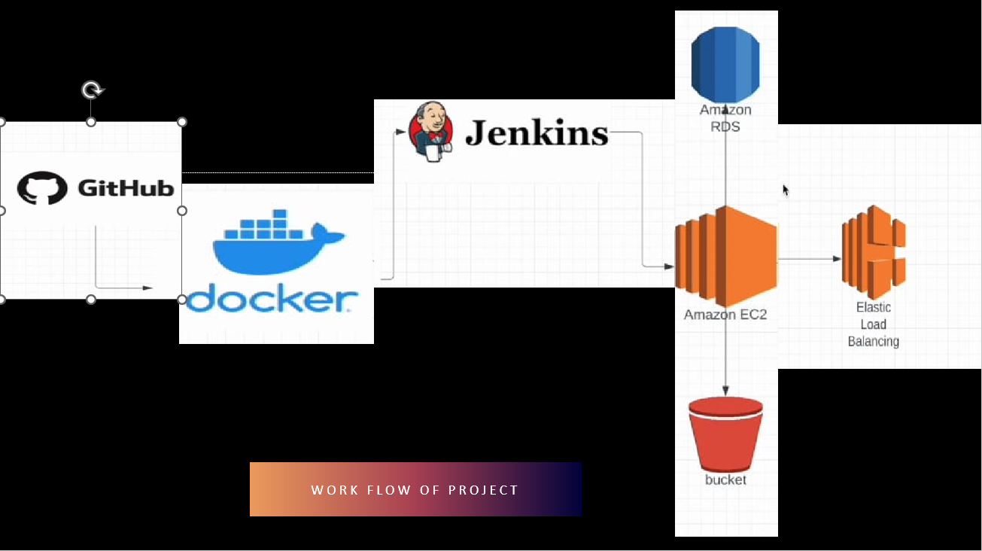

Figure 4.1(Project’s Image)

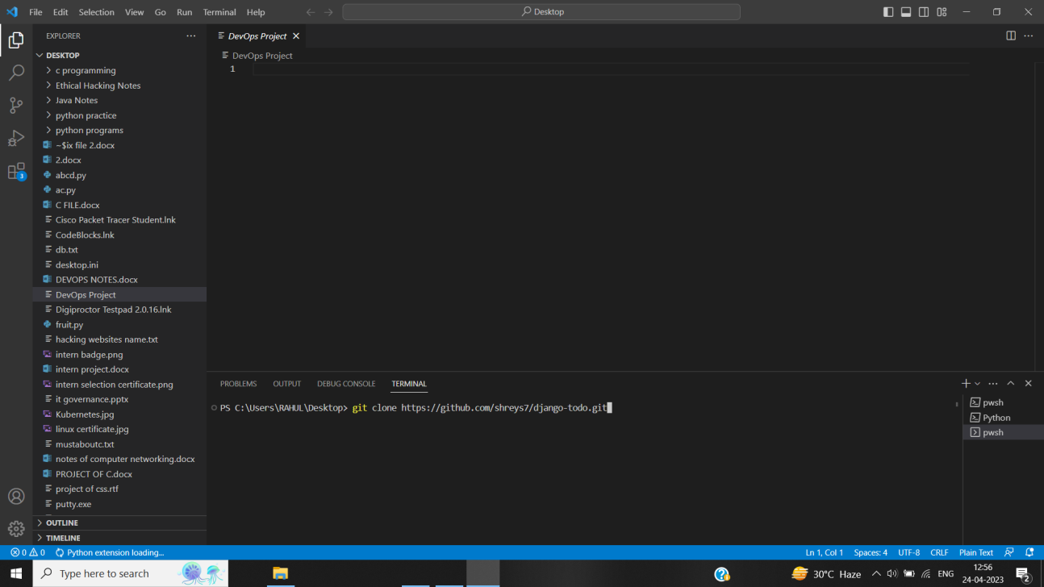

Figure 4.2(Deploy app)

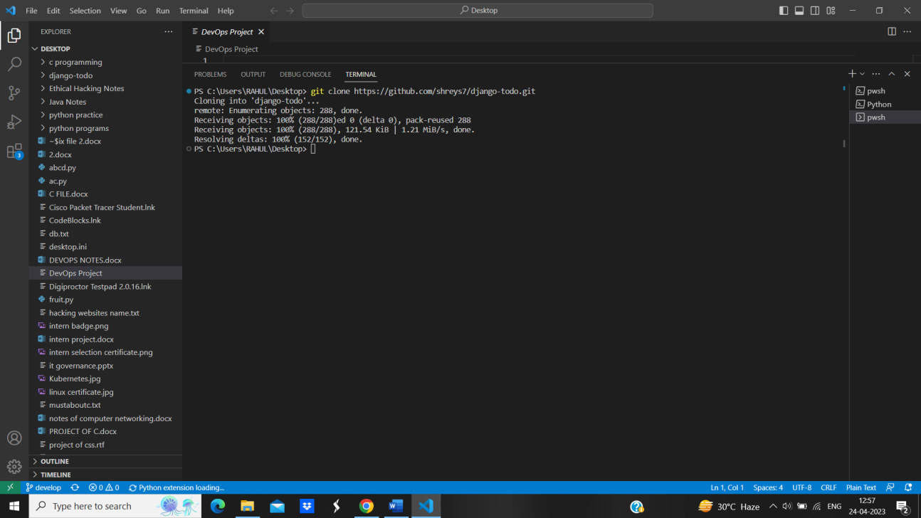

Figure 4.3(Cloning WebApp)

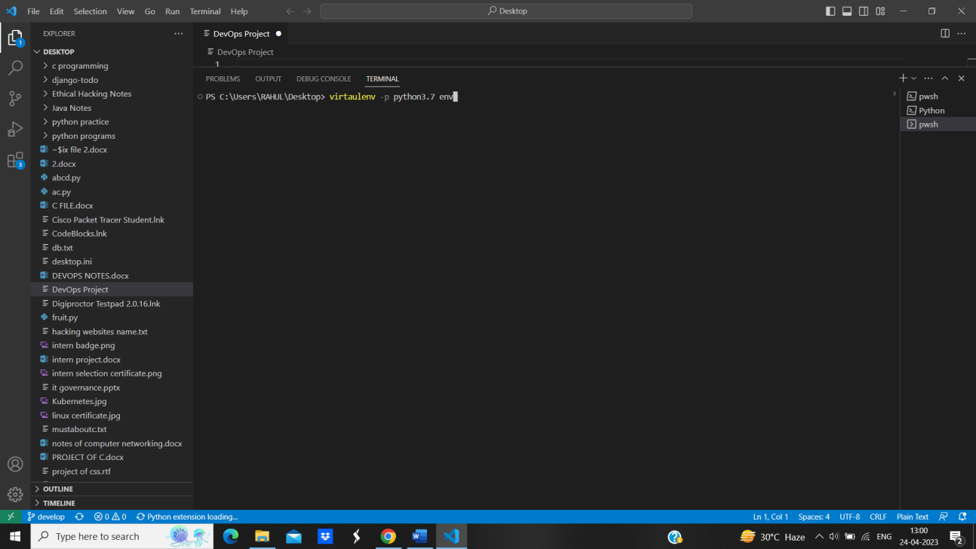

Figure 4.4 (Installing Python)

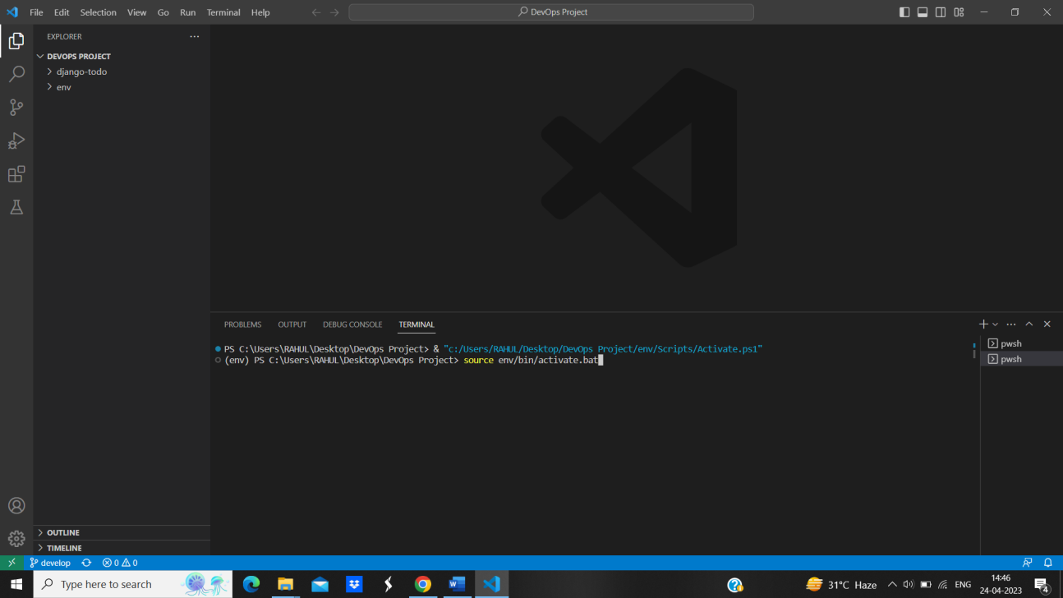

Figure 4.5 (Creating Virtual Env)

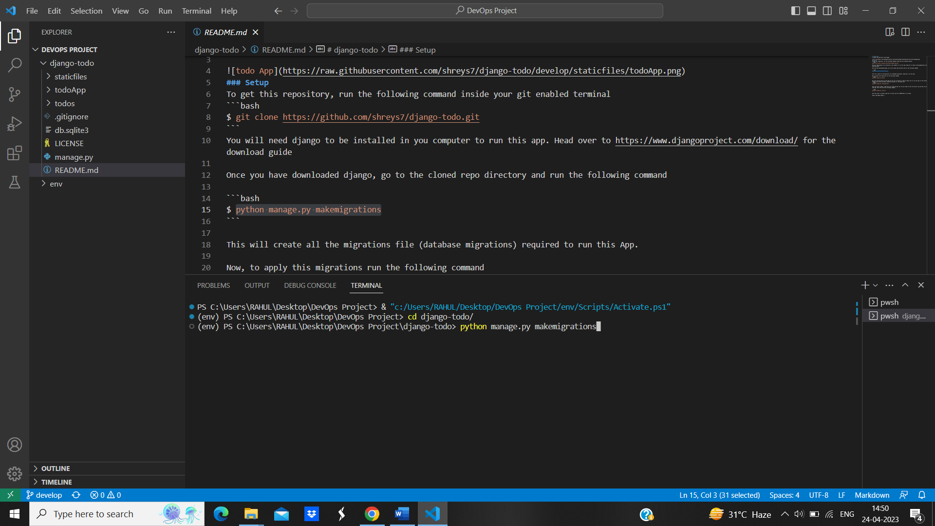

Figure 4.6 (Python Migration)

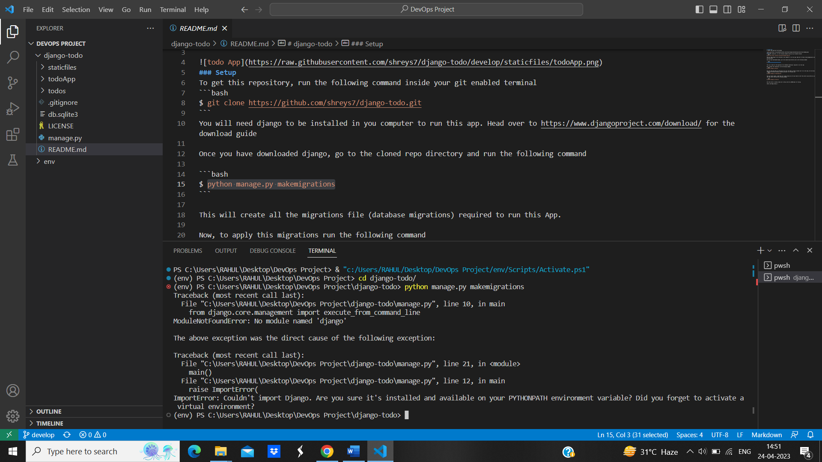

Figure 4.7 (Changing Directory)

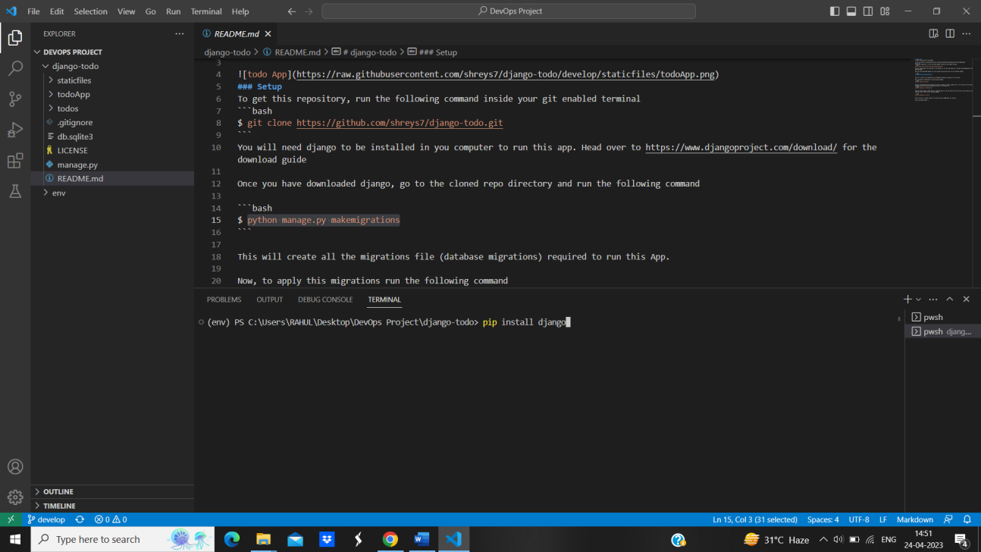Figure 4.8 (Installing Django)

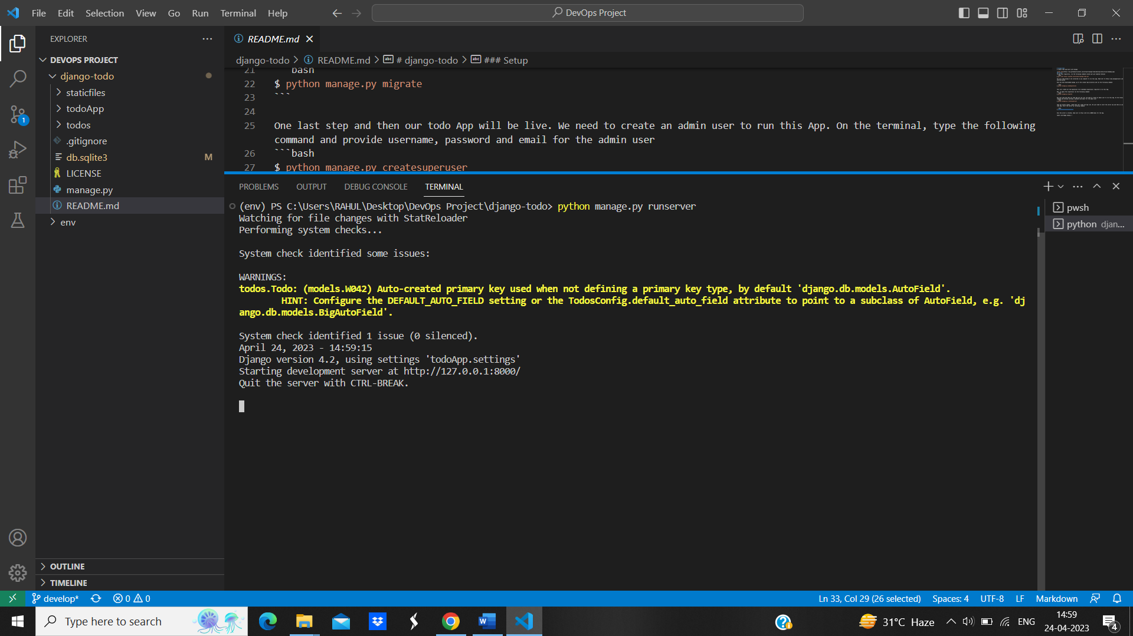

Figure 4.9 (Changing Port)

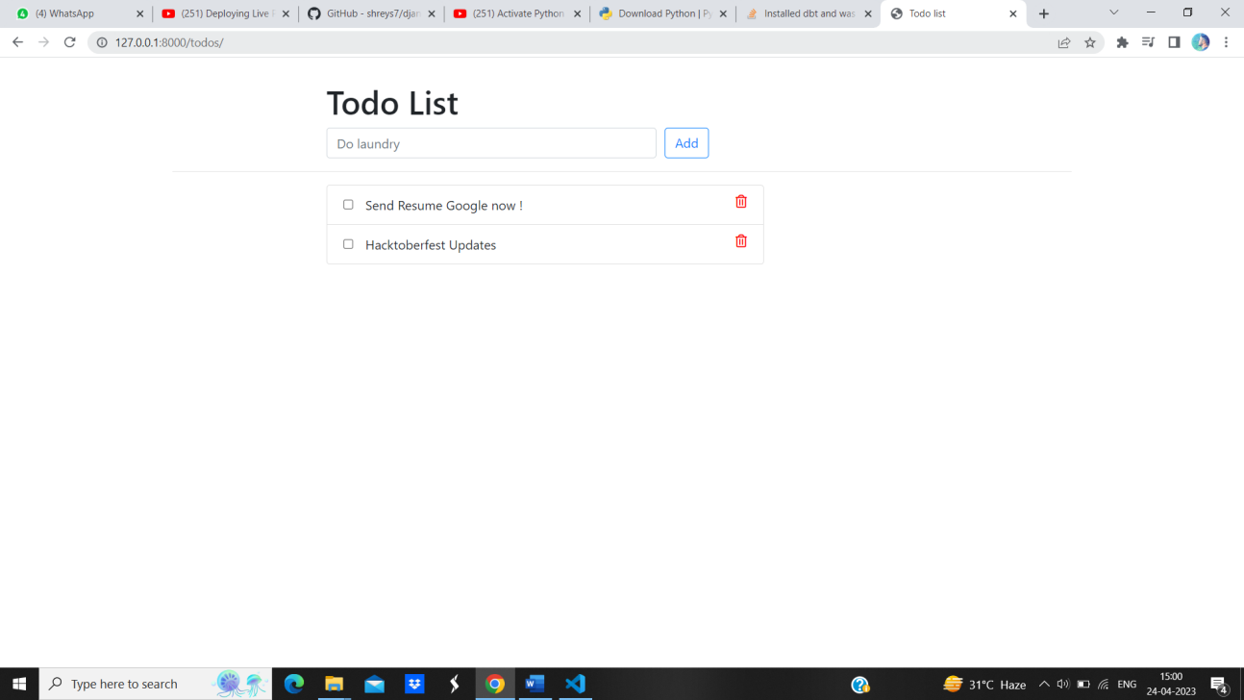

Figure 4.10 (Deployed WebApp)

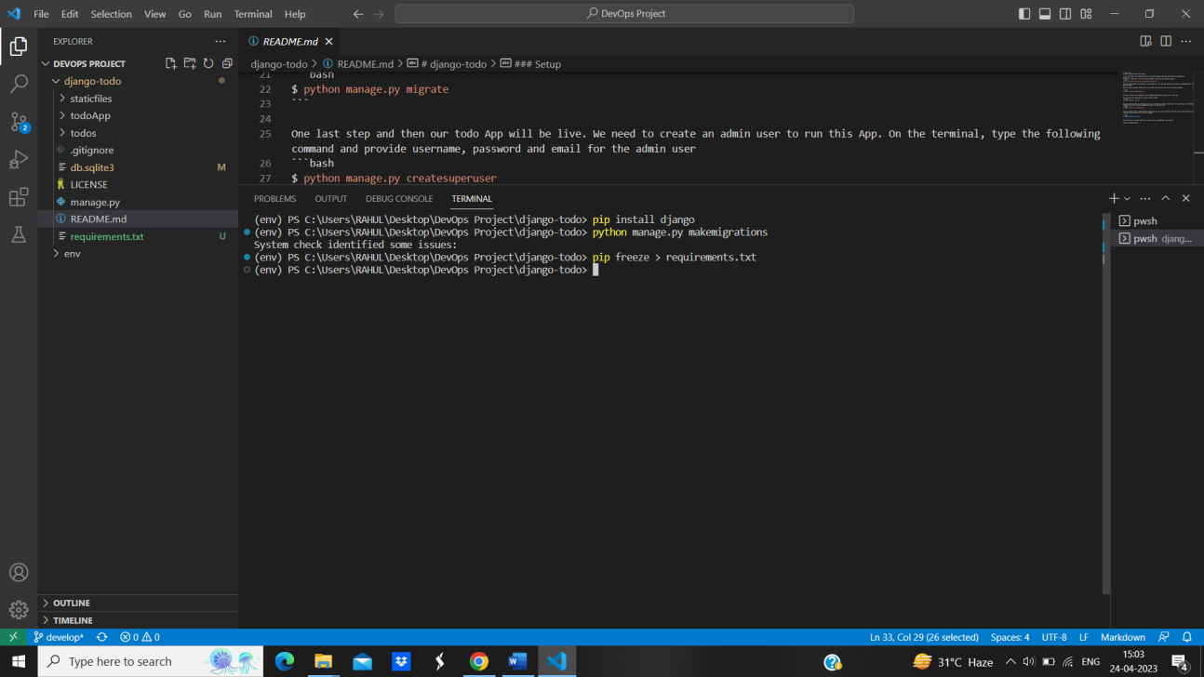

Figure 4.11 (Retrieved Dependencies)

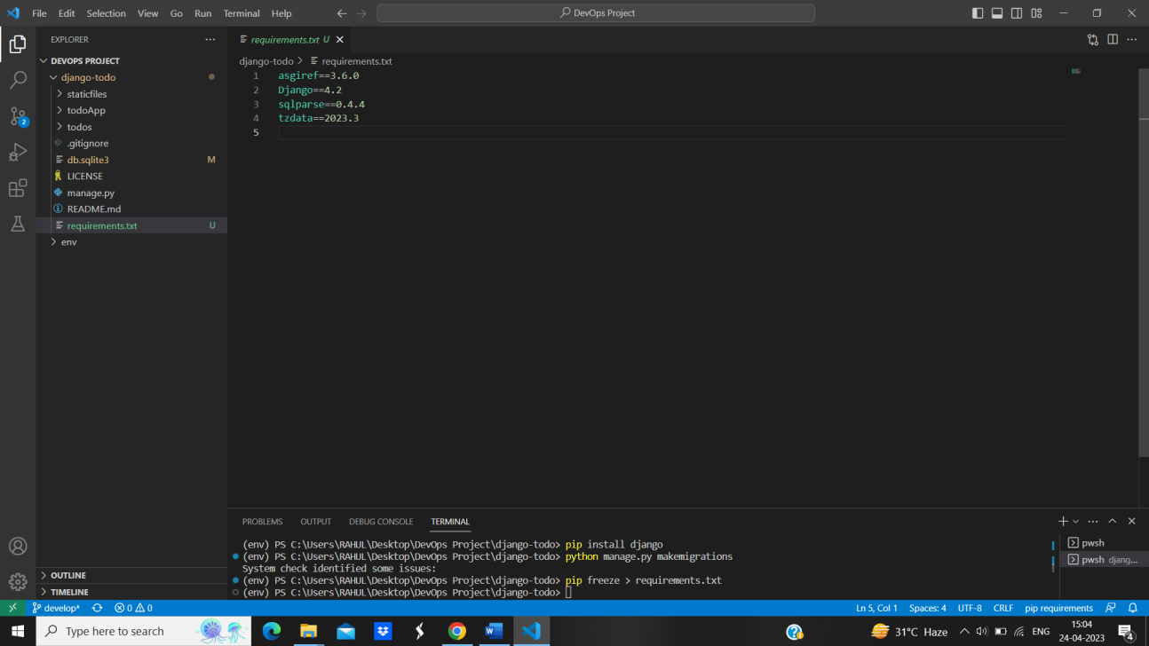

Figure 4.12 (Files)



Figure 4.13 (Log into AWS)

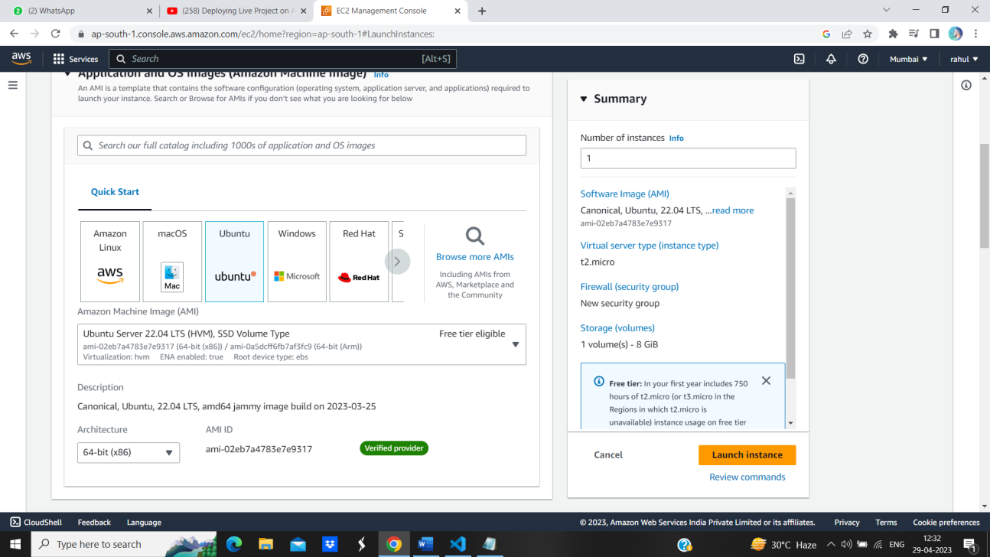

Figure 4.14 (Choose Ubuntu)

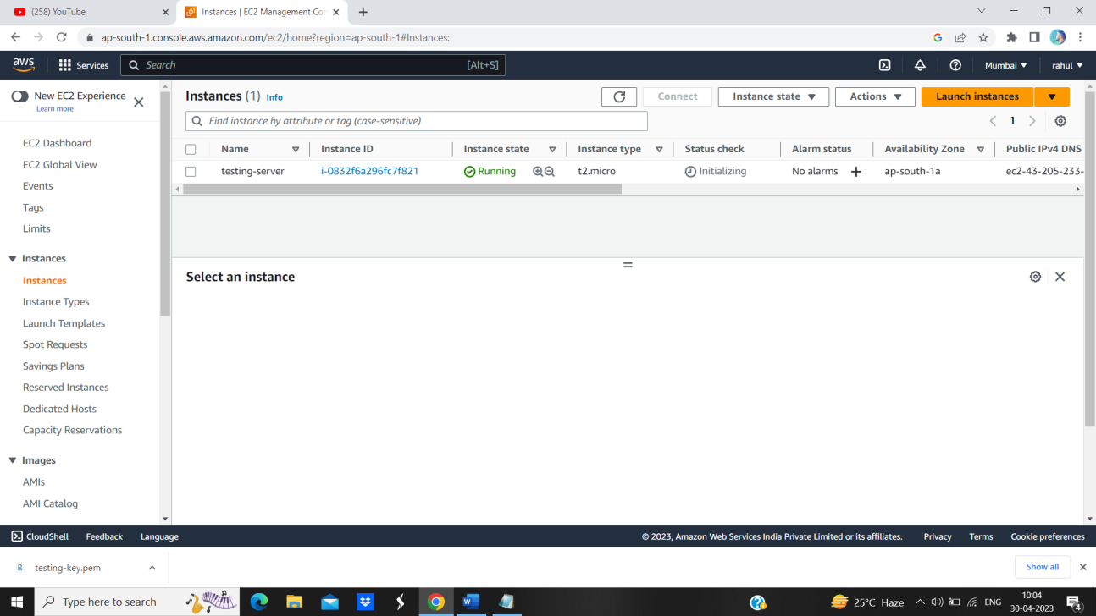

Figure 4.15 (Launch Instance)

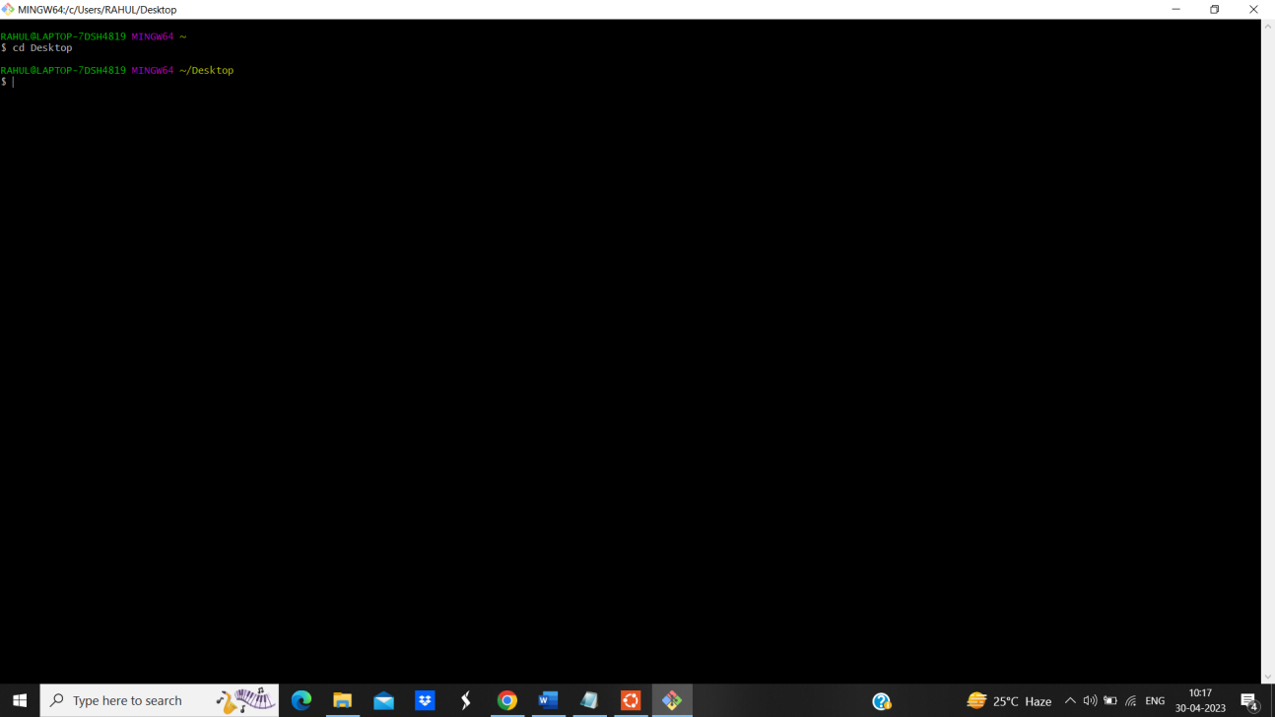

Figure 4.16 (Log into Ubuntu)

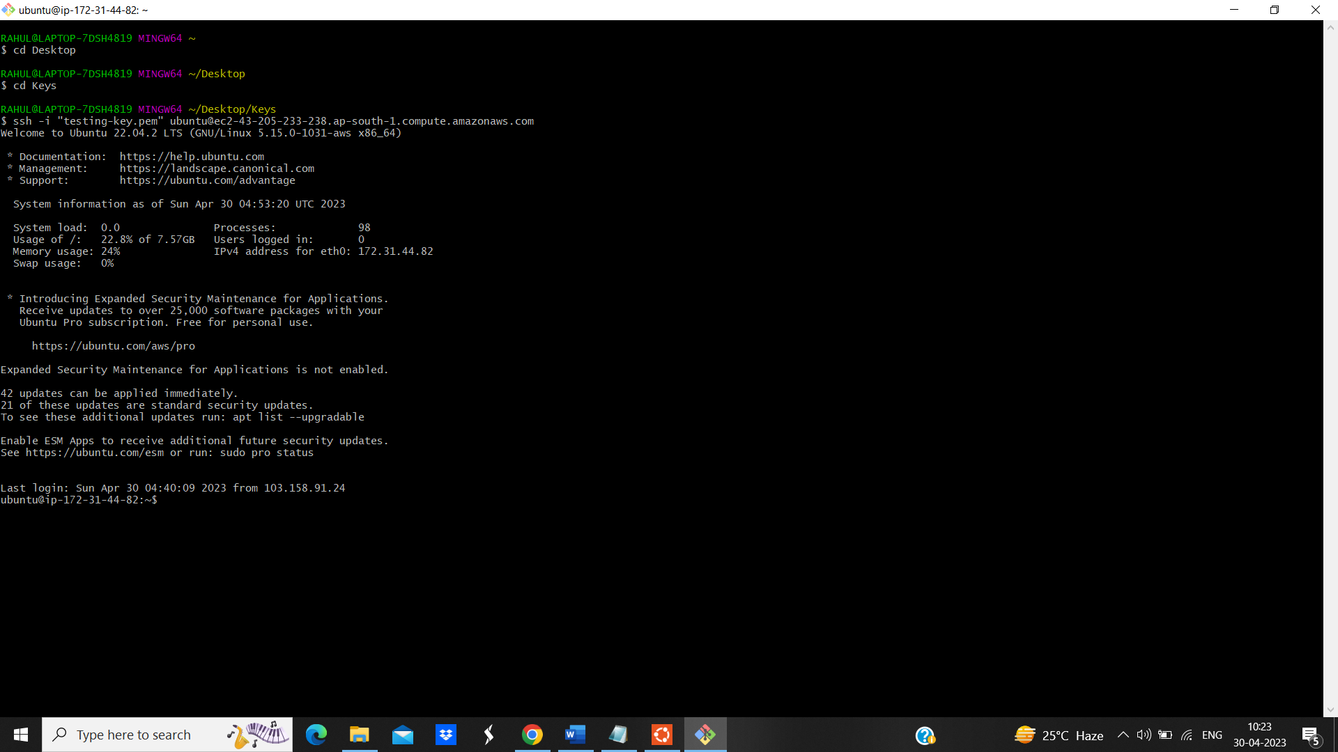

Figure 4.17 (Accessed Ubuntu)

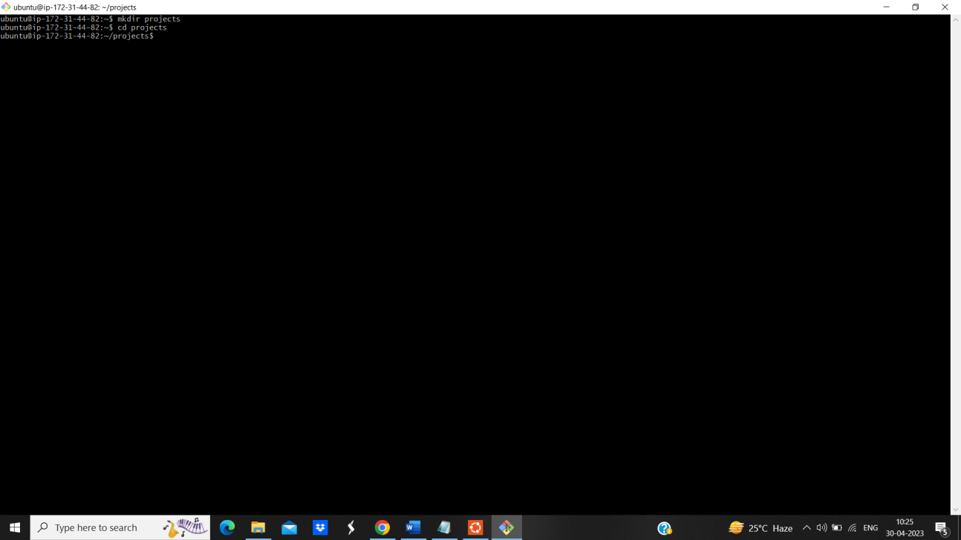

Figure 4.18 (Changed Directory)

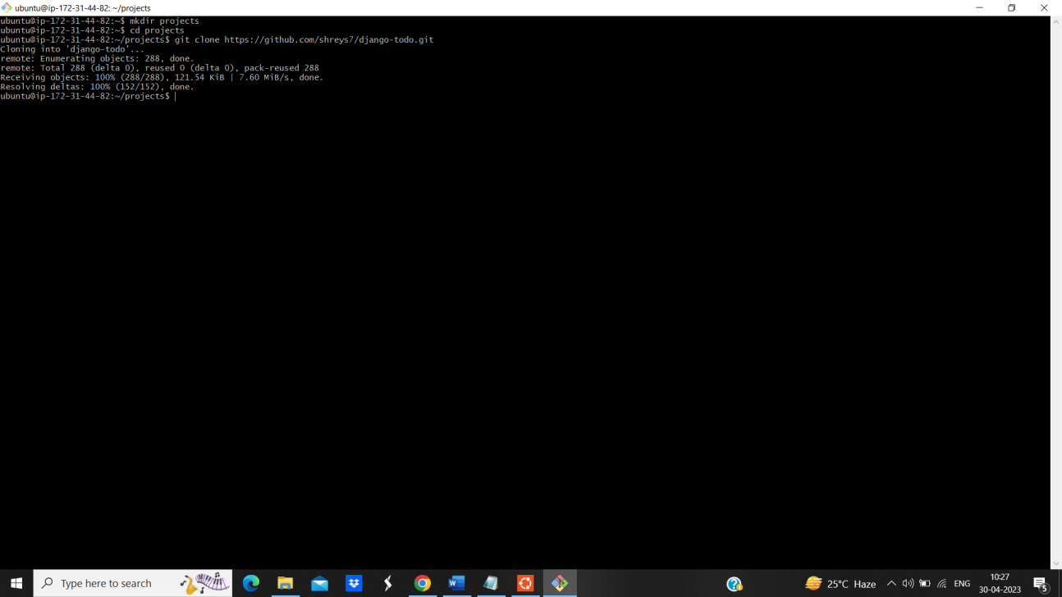

Figure 4.19 (WebApp Cloning to Ubuntu)

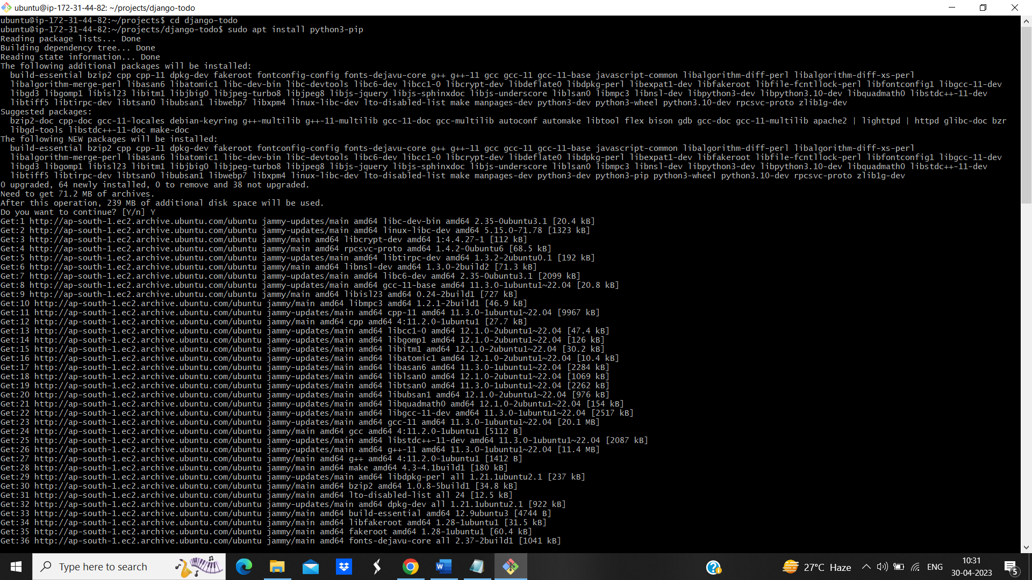

Figure 4.20 (Installed Pip Python)

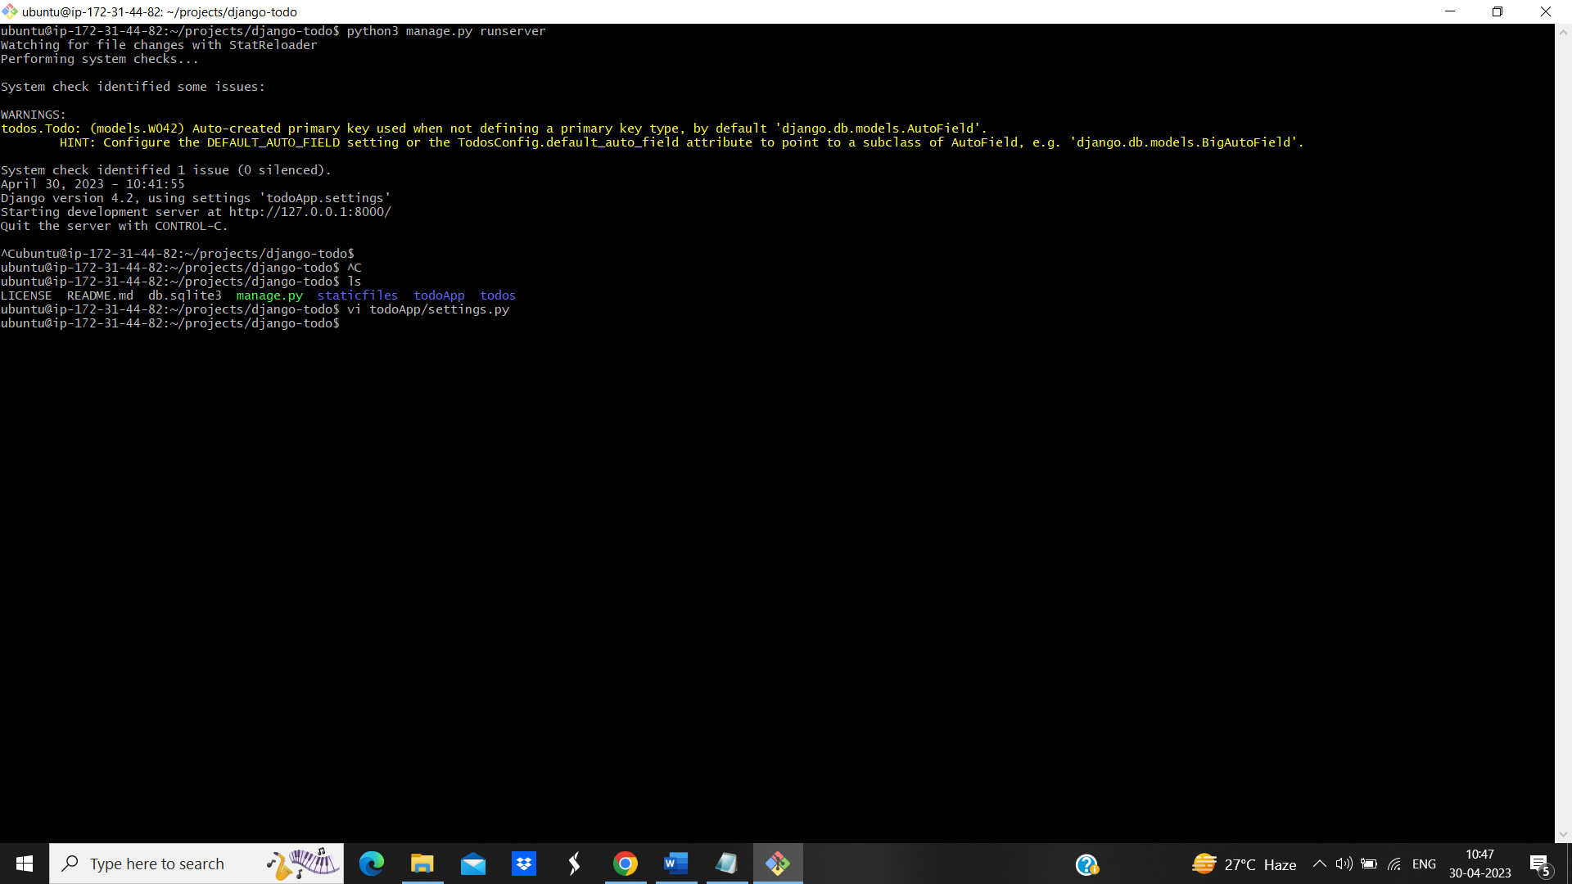

Figure 4.21 (Changing to Settings.py)

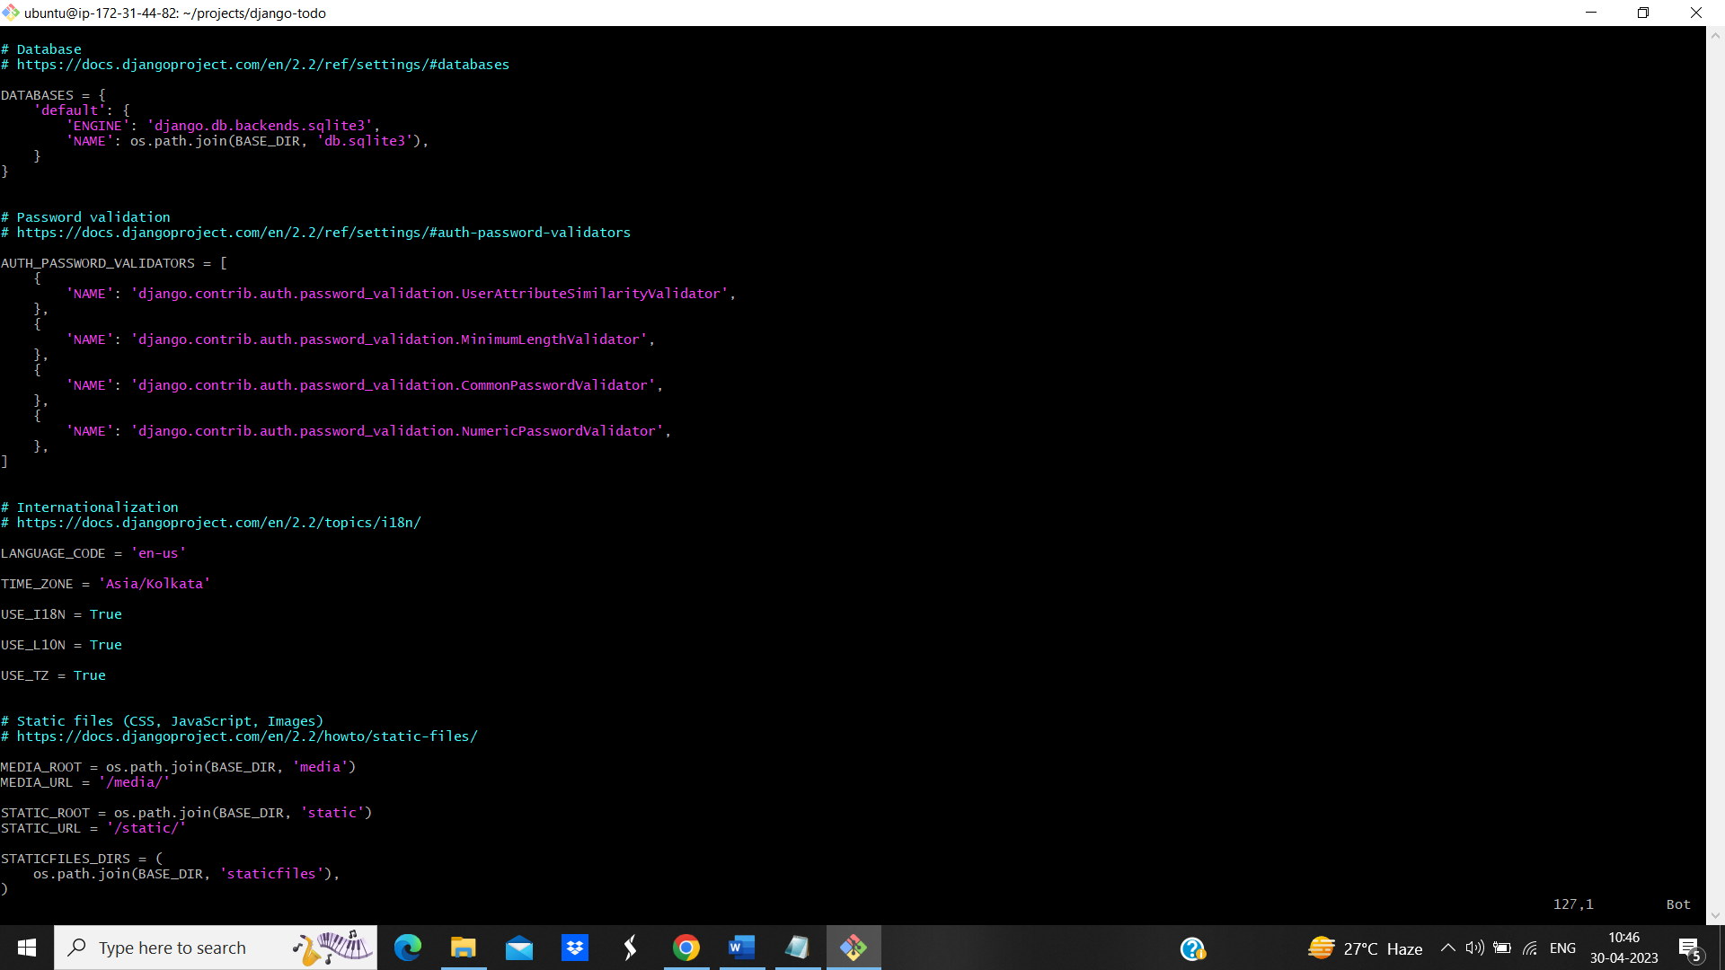

Figure 4.22 (Changed Ip and Time zone)

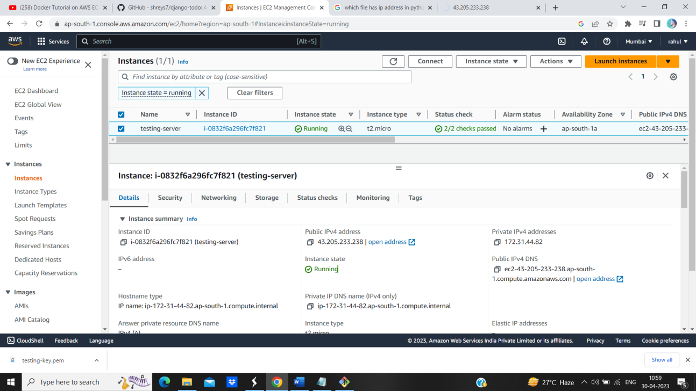

Figure 4.23 (Copying Public IP)

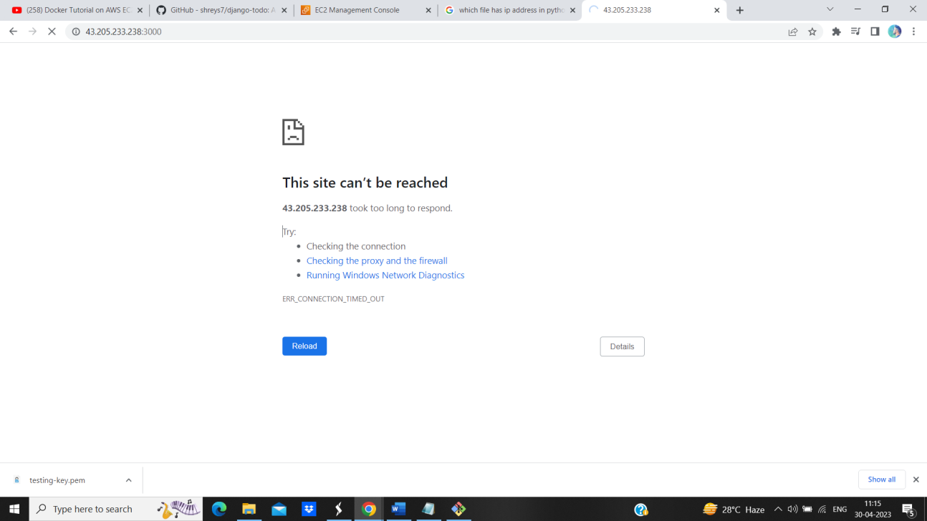

Figure 2.24 (WebApp not running)

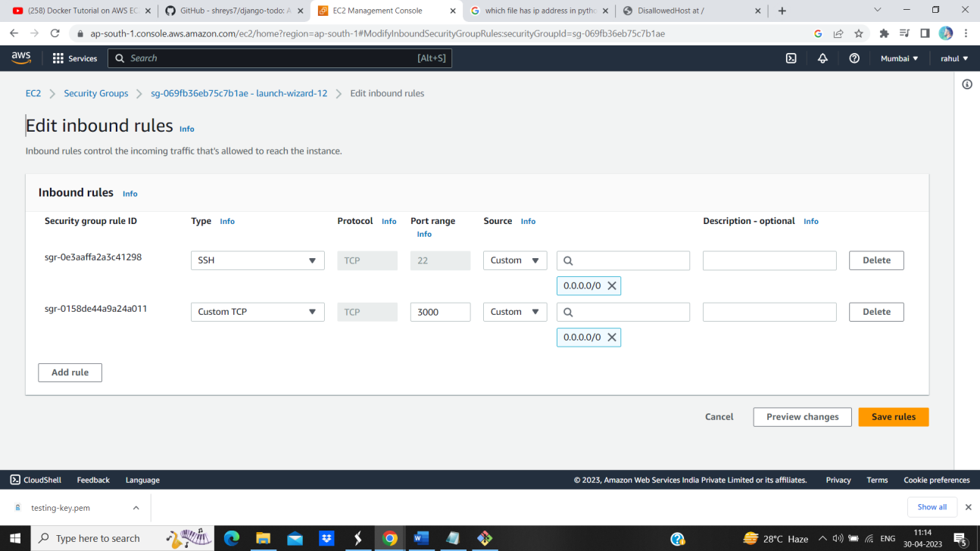

Figure 4.25 (Allowed traffic on port)

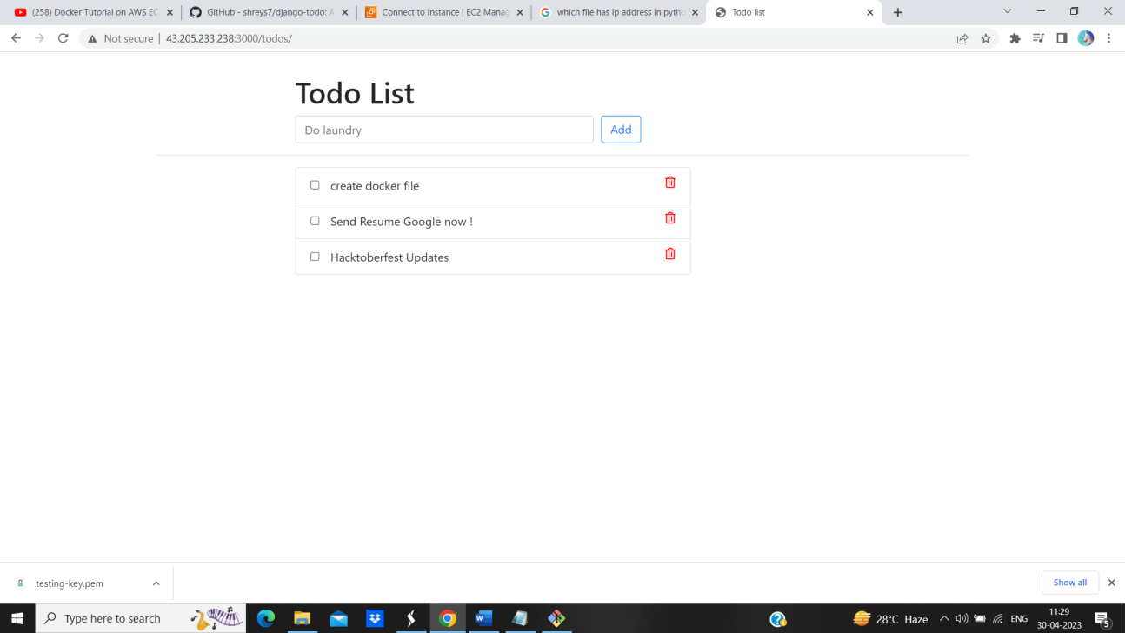

Figure 4.26 (WebApp is running and checked)

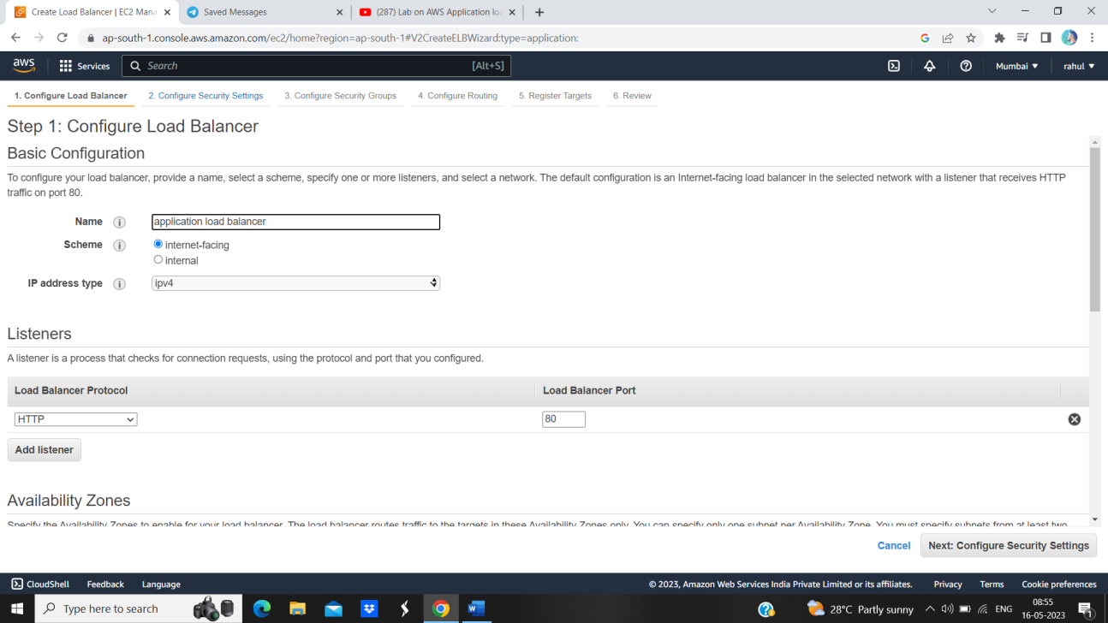

Figure 4.27 (Creating Load Balancer)

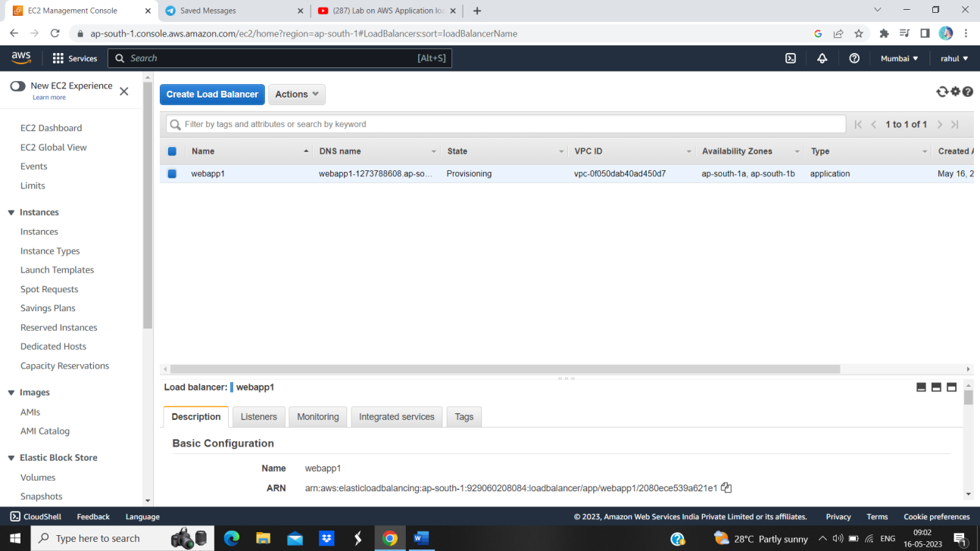

Figure 4.28 (Load Balancer Launched)

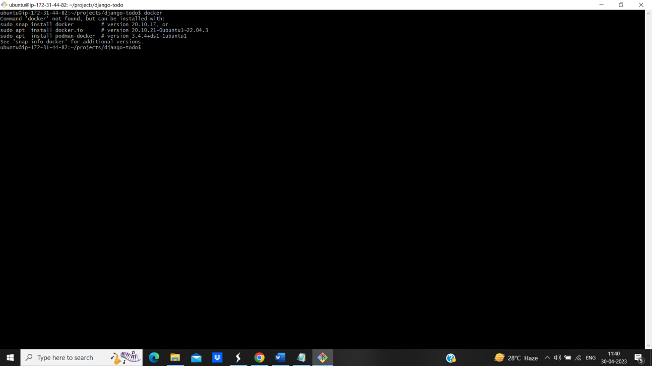

Figure 4.29 (Installing Docker)

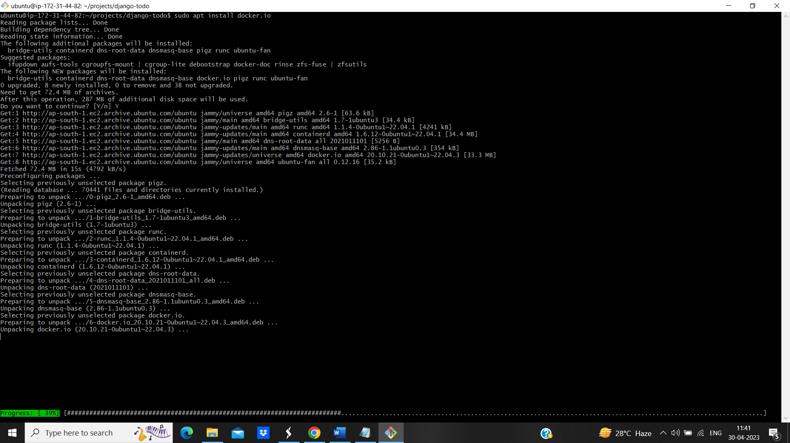

Figure 4.30 (In progress)



Figure 4.31 (Creating Docker File)

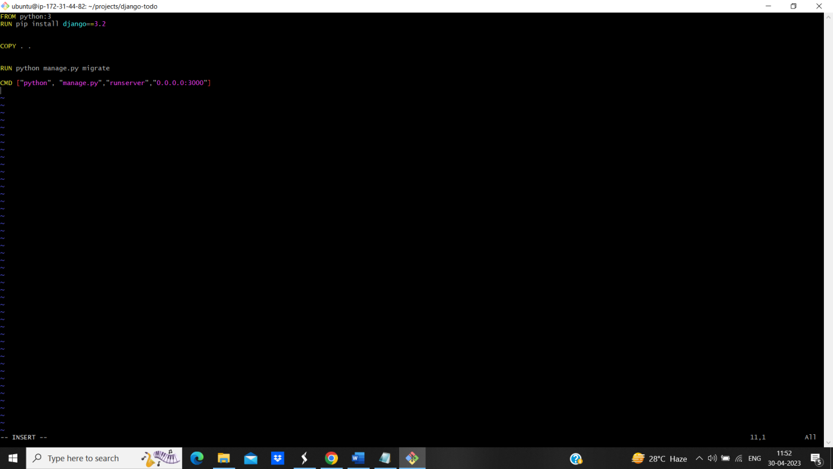

Figure 4.32 (Write Script)

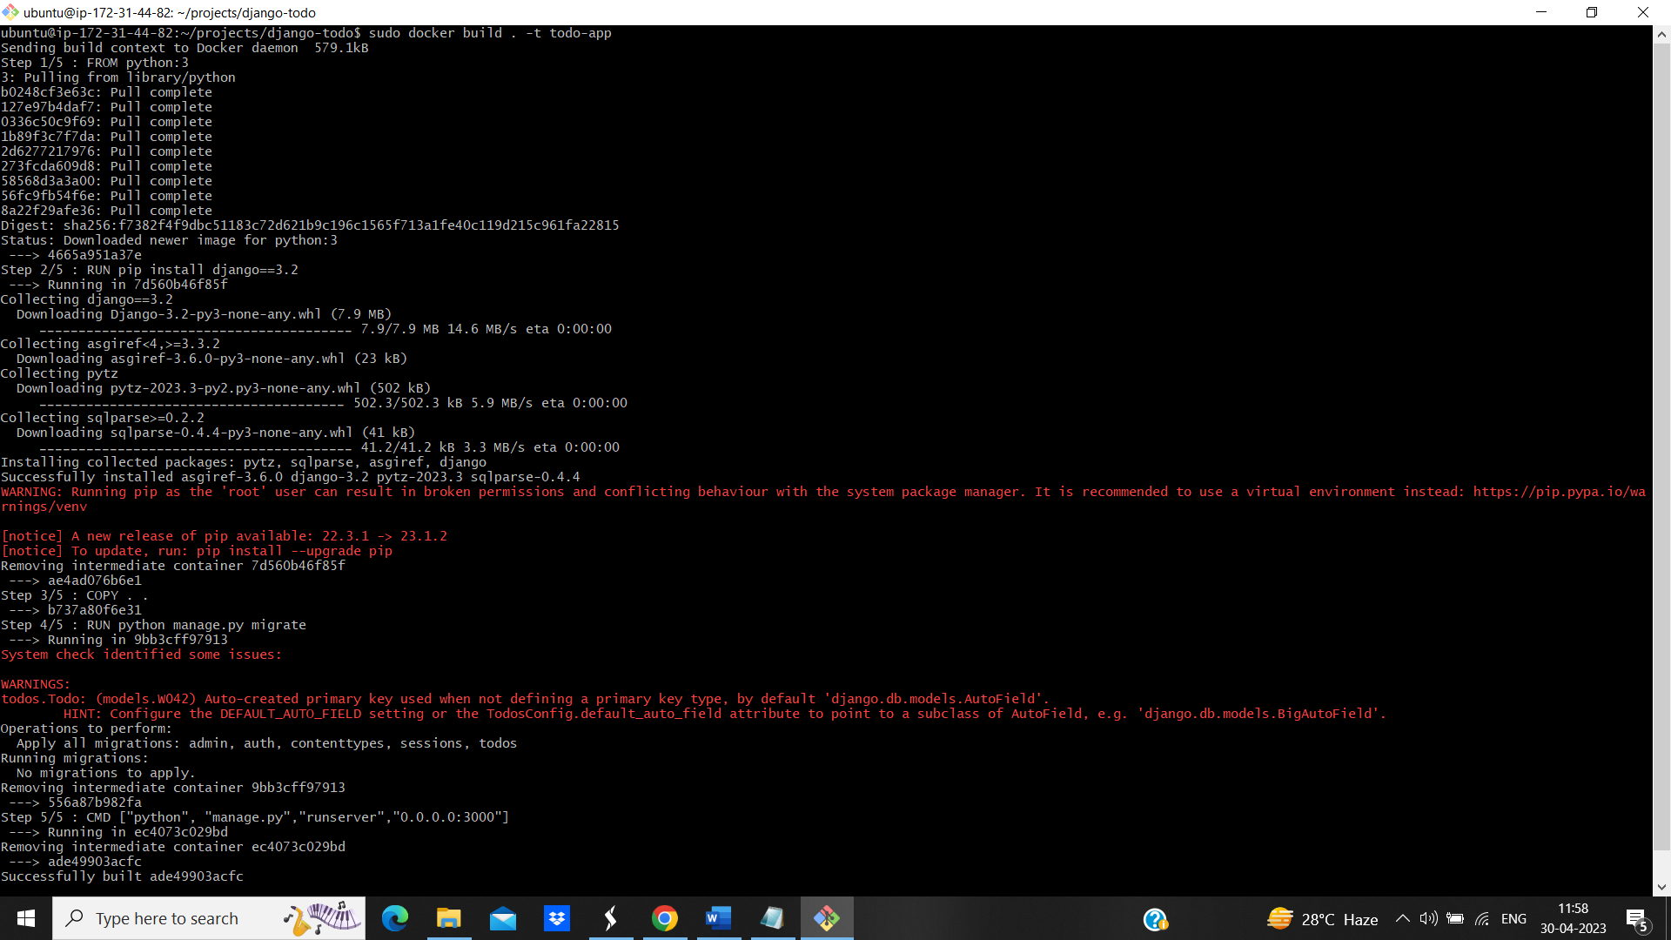

Figure 4.33 (Script Executing)



Figure 4.34 (Checked Containers)



Figure 4.35 (Running Container)

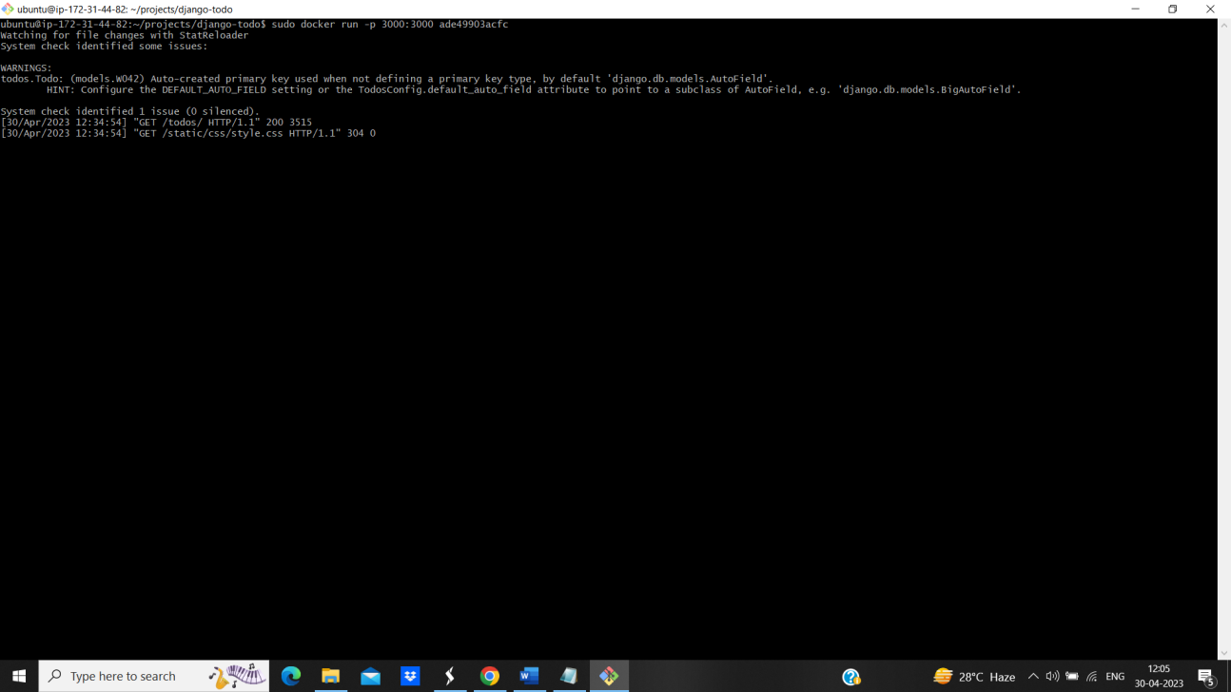

Figure 4.36 (Diverting traffic to port 3000)

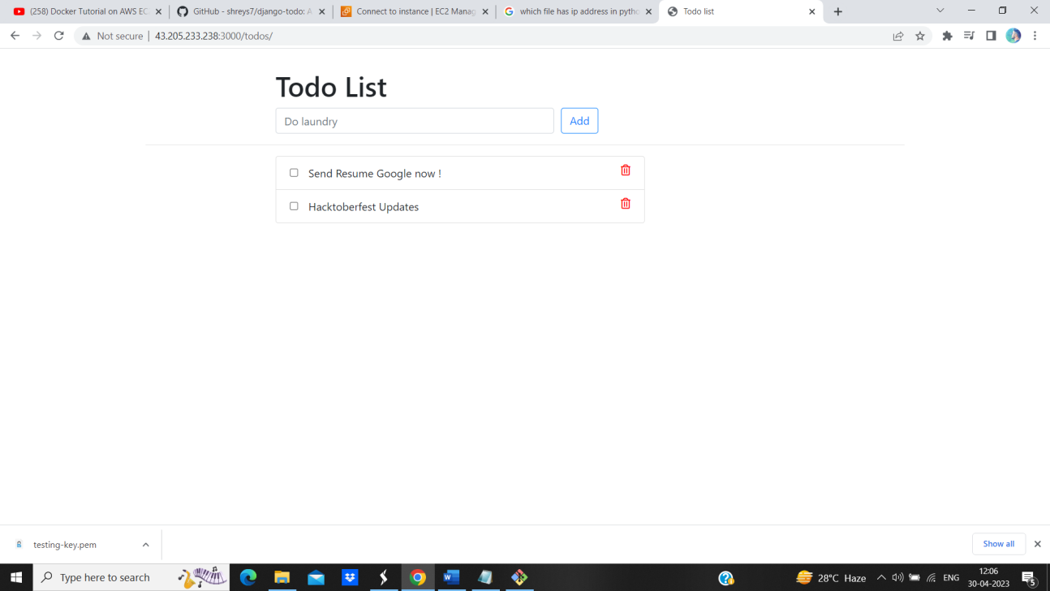

Figure 4.37 (App Deployed)

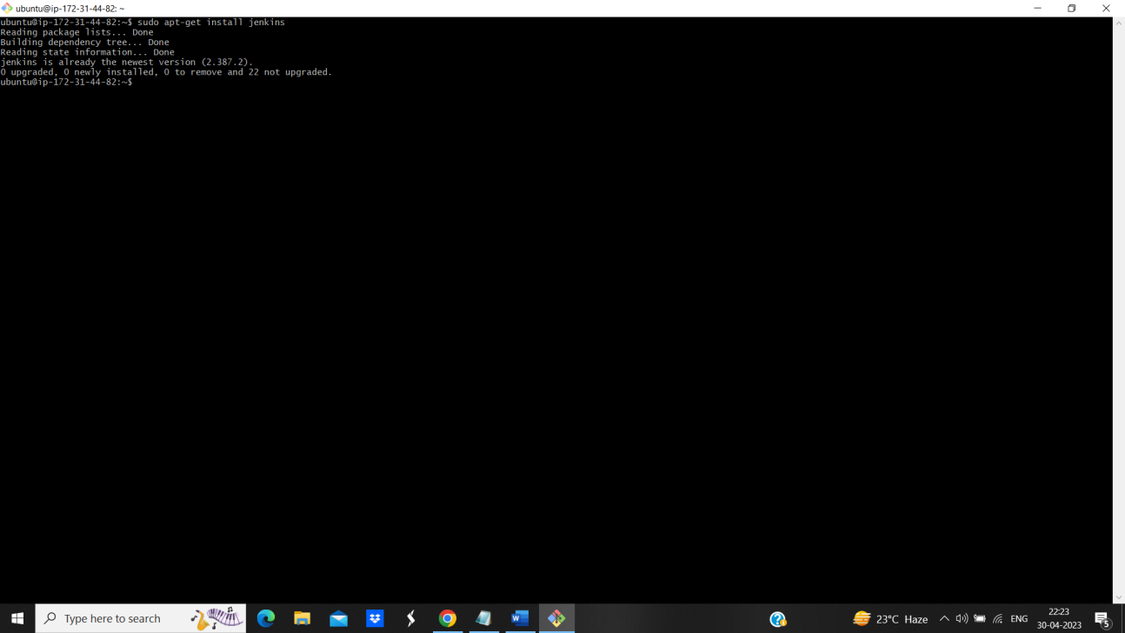

Figure 4.38 (Installing Jenkins)

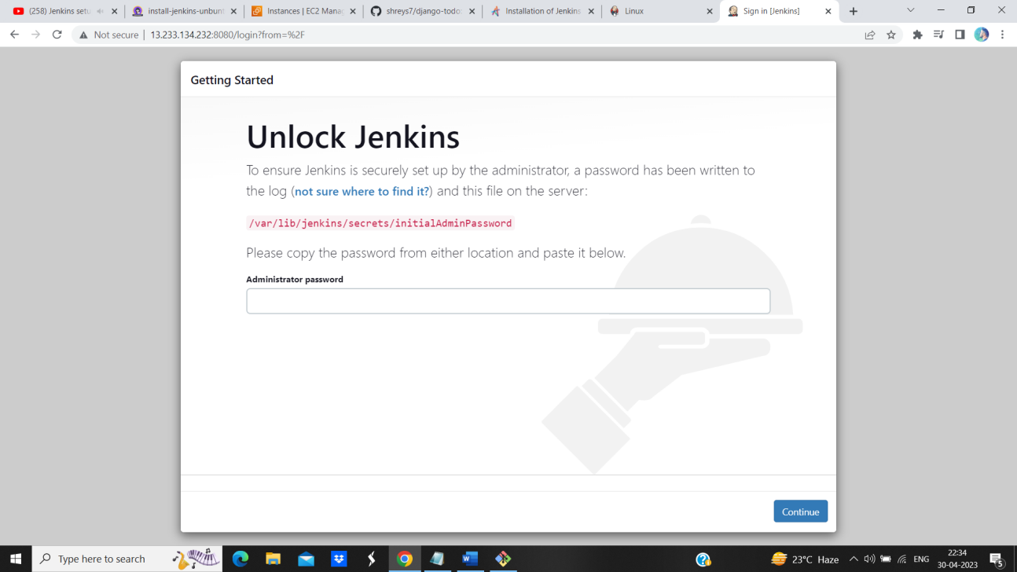

Figure 4.39 (Jenkins Installed)

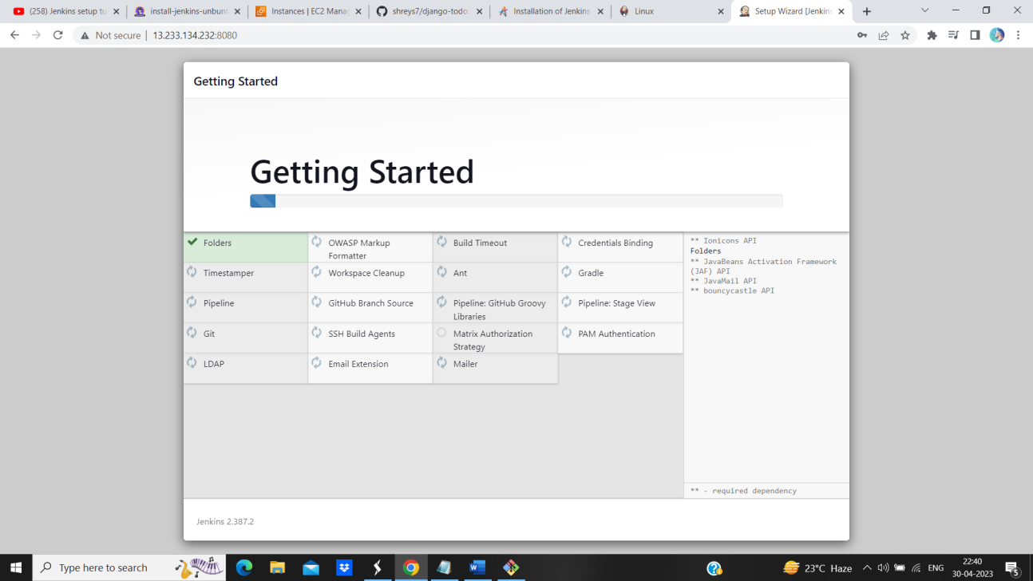

Figure 4.40 (Installing Plugins)

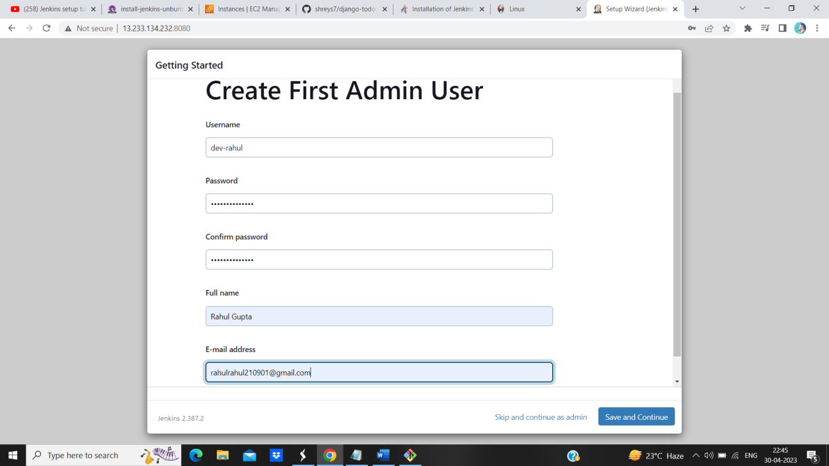

Figure 4.41 (Creating Admin)

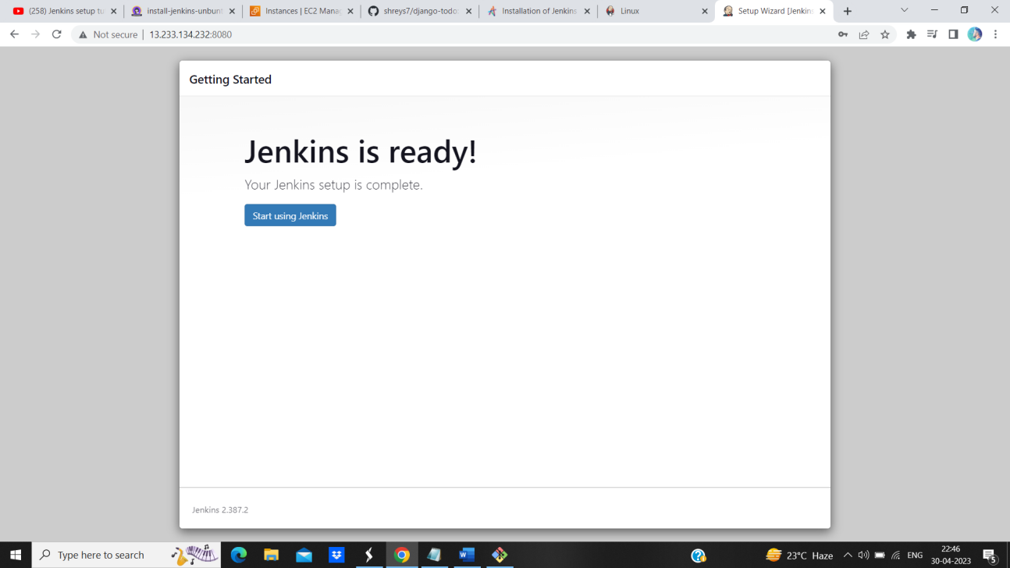

Figure 4.42 (Ready to use)

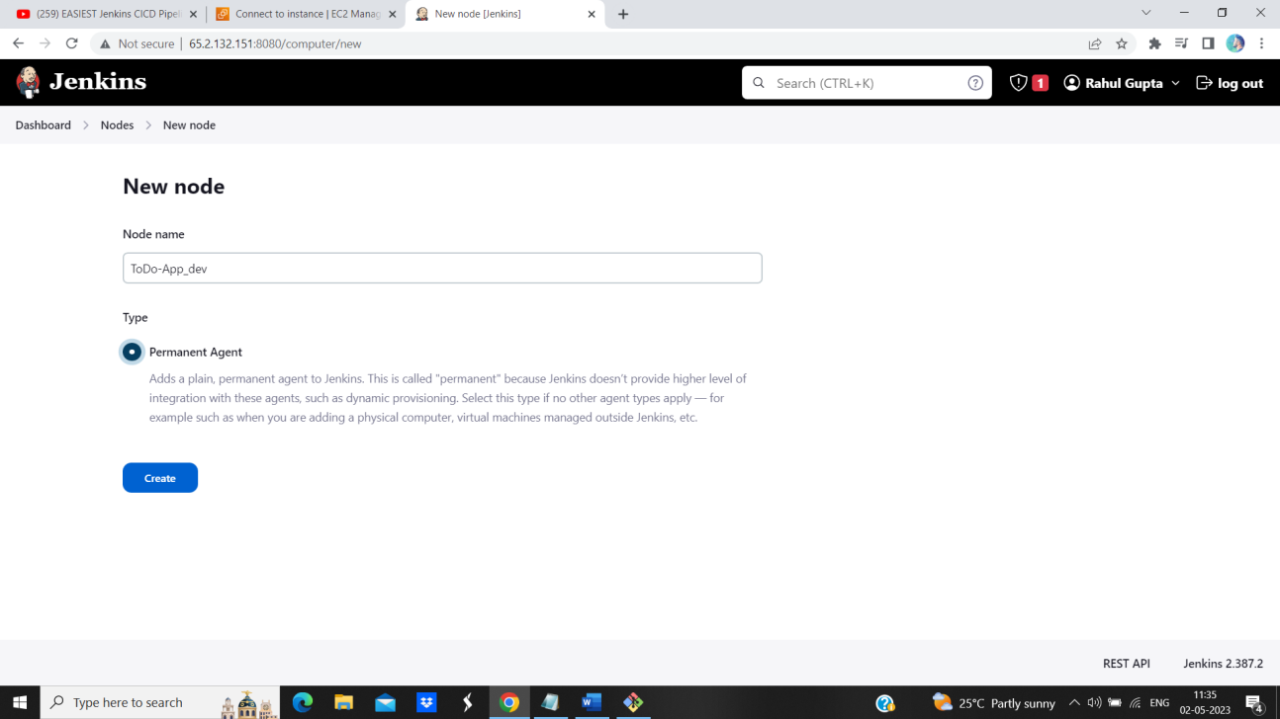

Figure 4.42 (Creating Node and Agent)

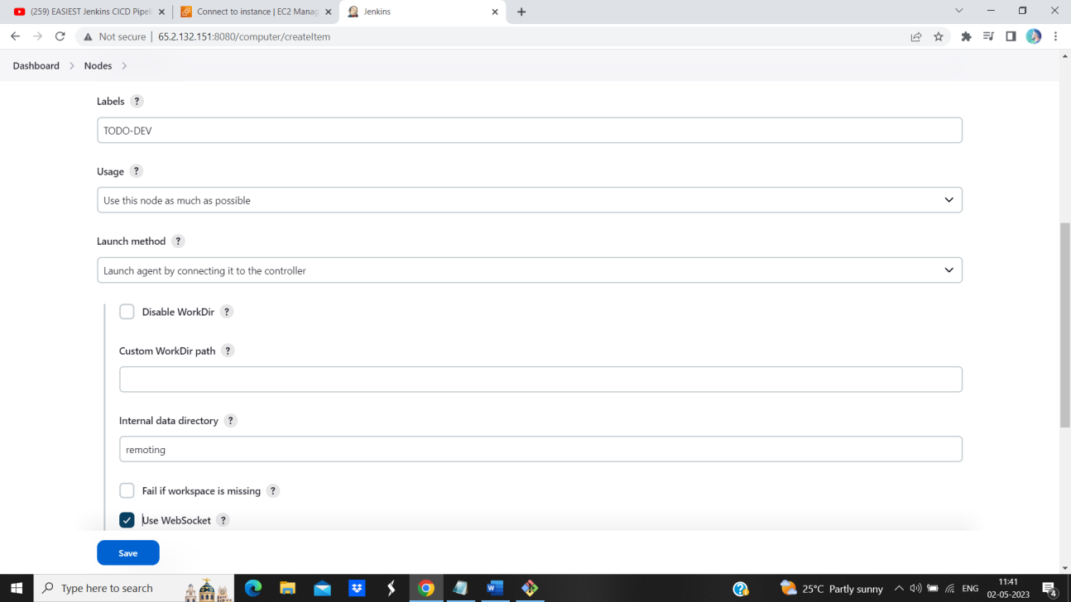

Figure 4.43 (Giving Permissions)

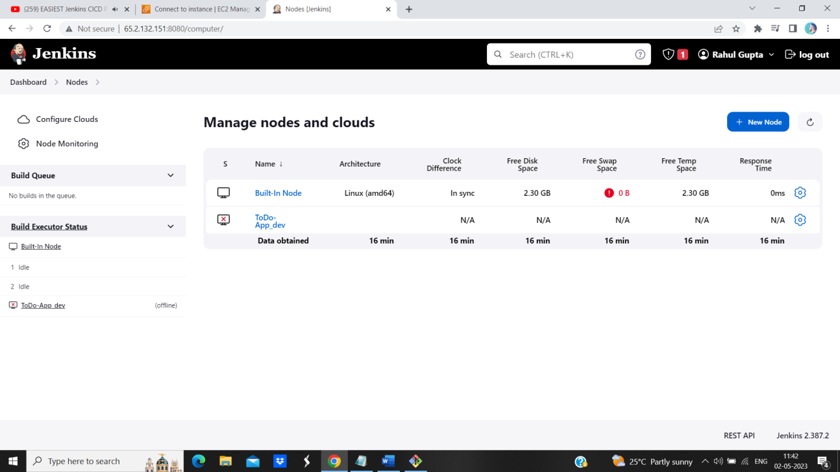

Figure 4.44 (Running WebApp)

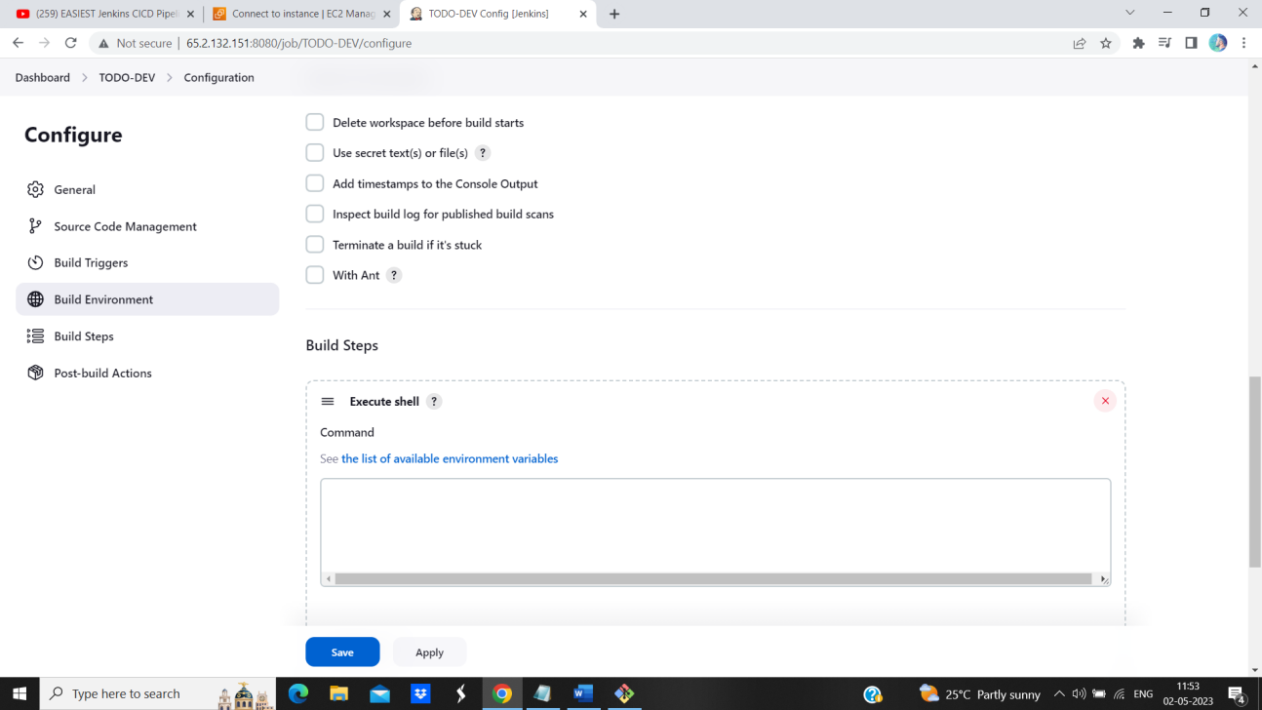

Figure 4.45 (Building Environment)

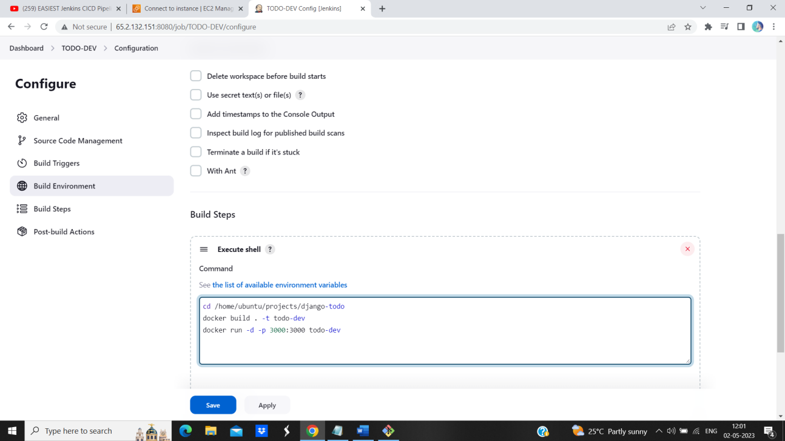

Figure 4.46 (Writing Script)

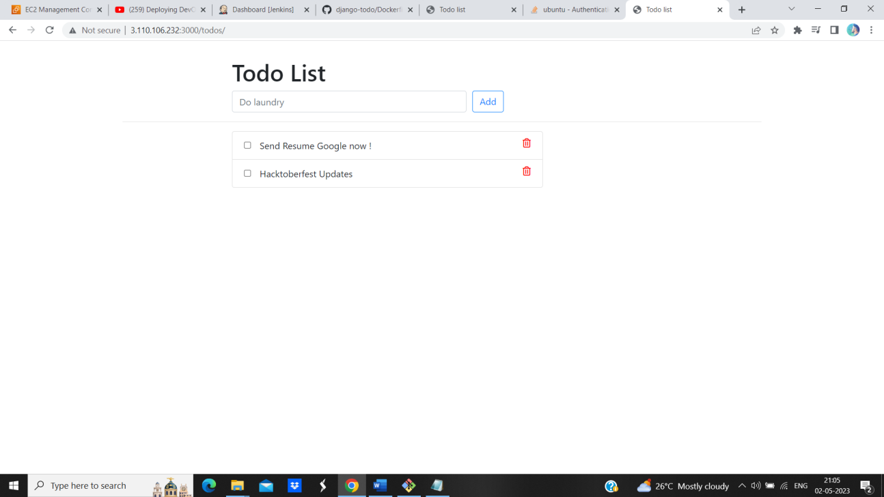

Figure 4.47 (WebApp is running)

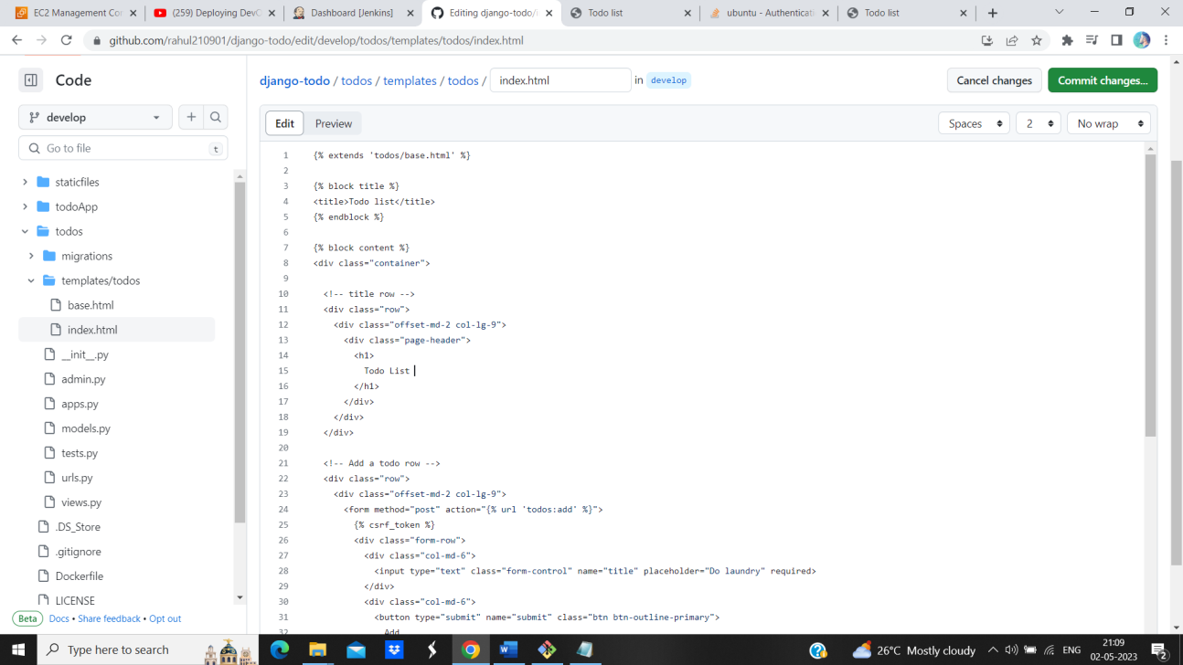

Figure 4.48 (Changing to code)

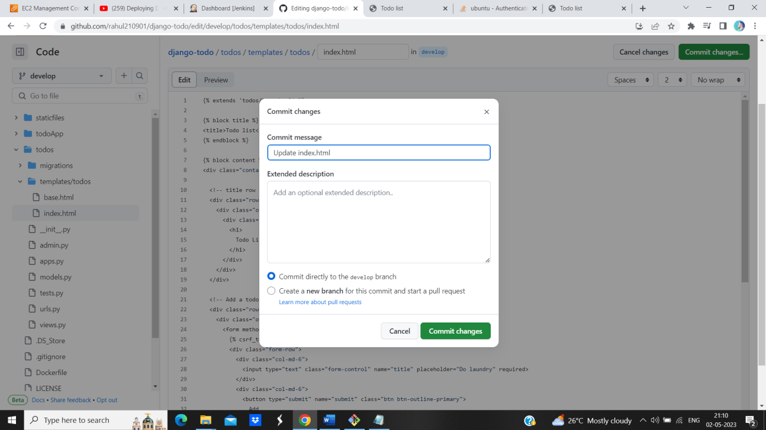

Figure 4.49 (Commit Change)

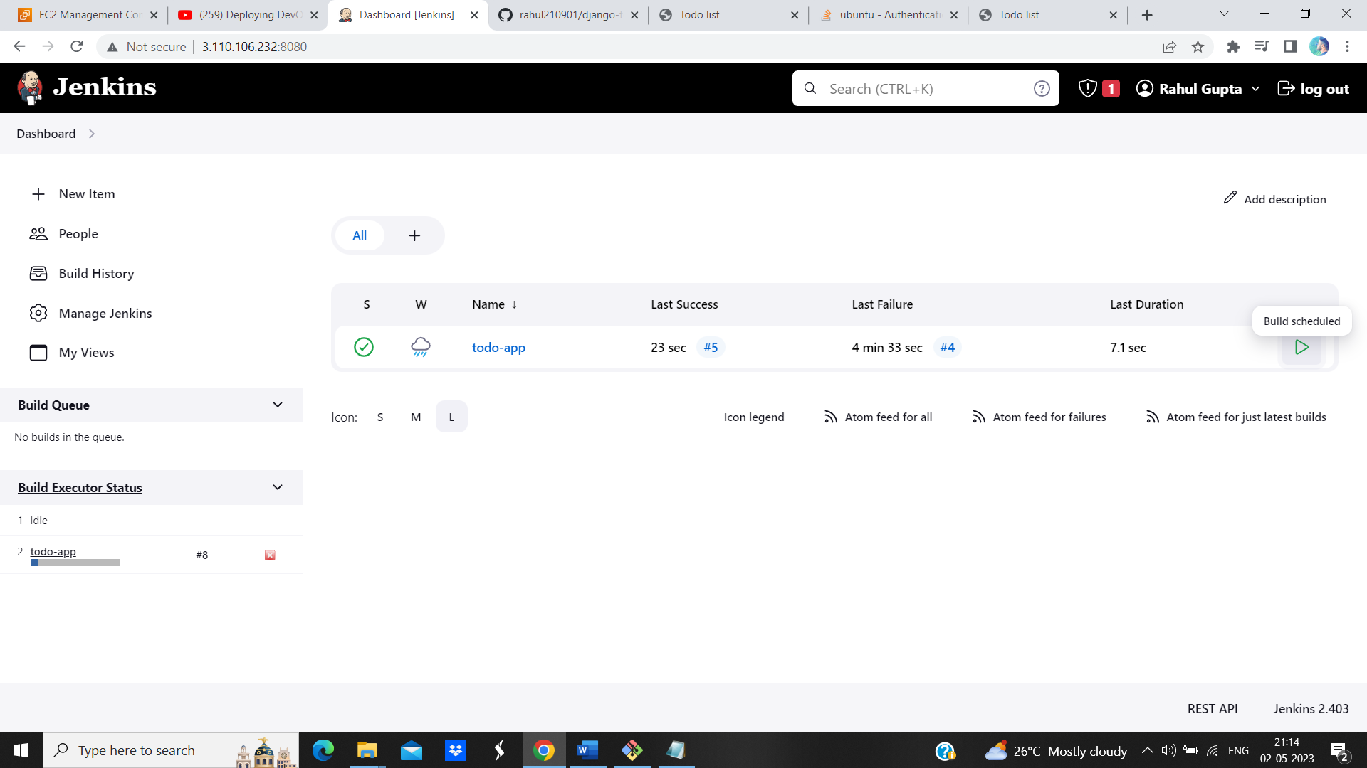

Figure 4.50 (Building WebApp)

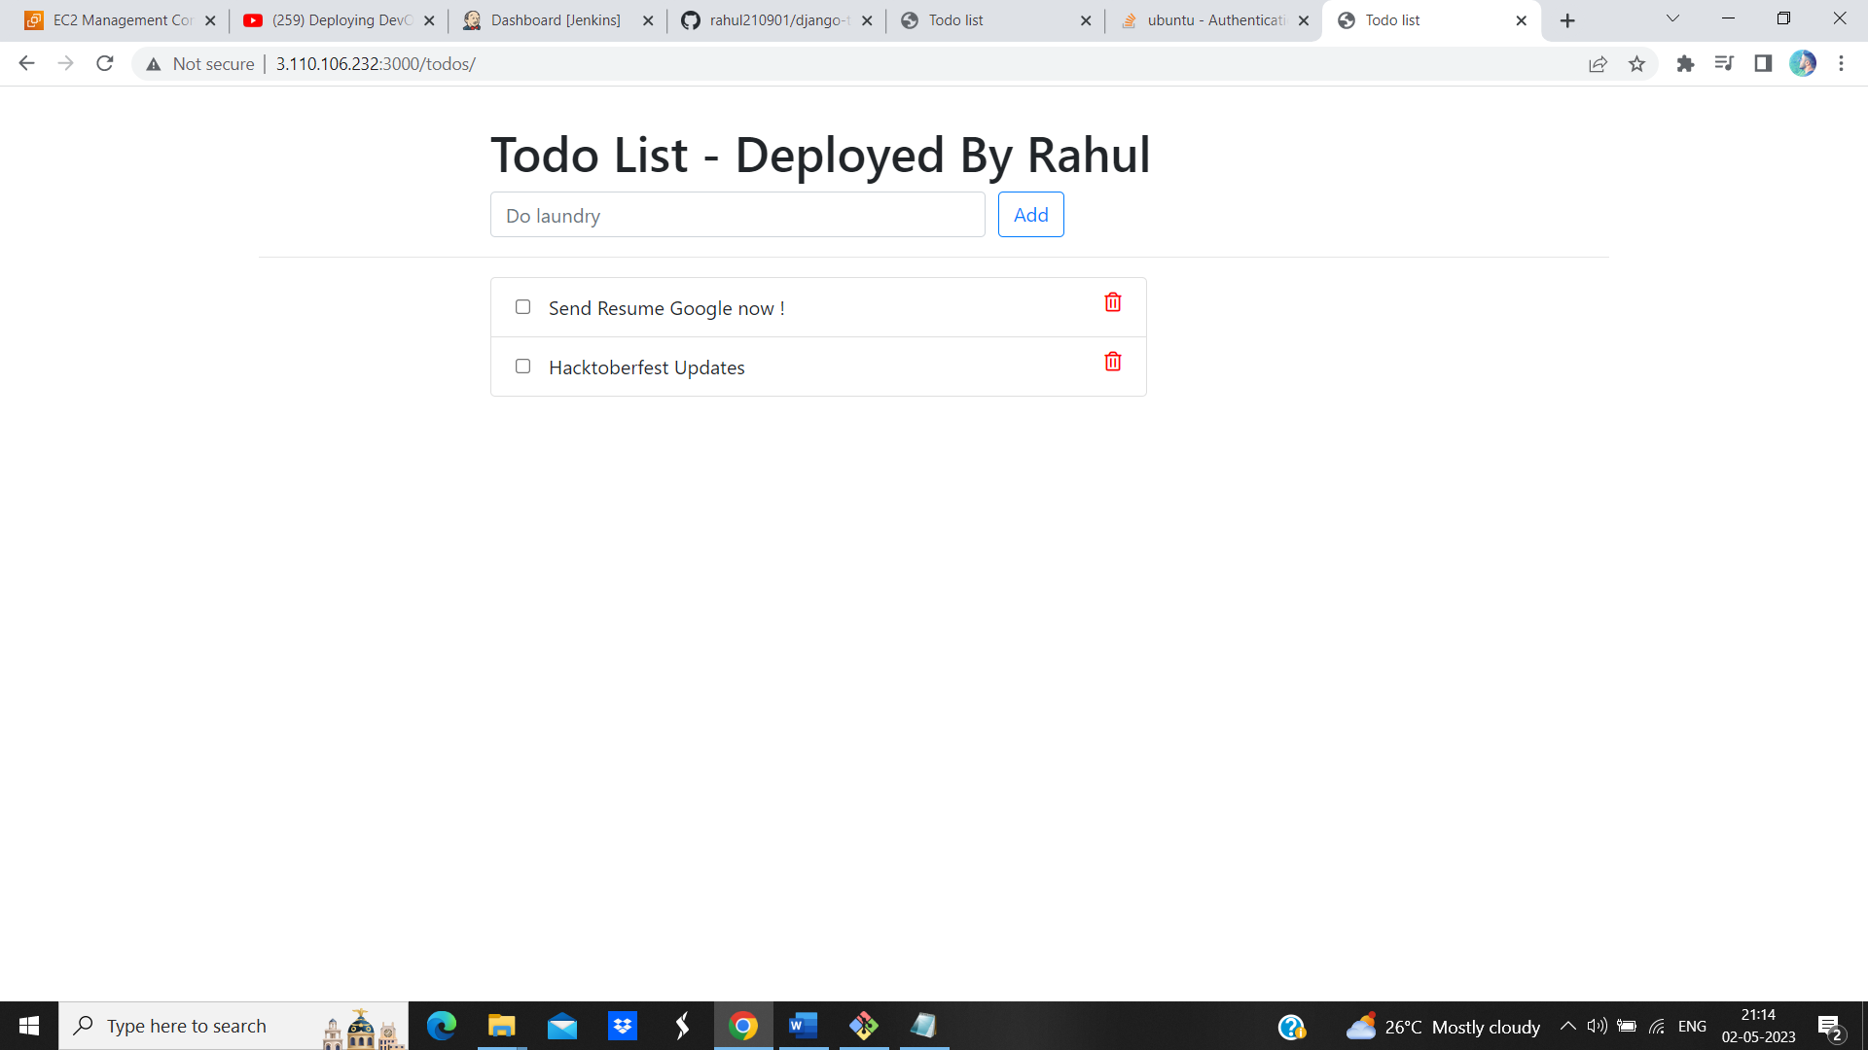

Figure 4.51 (App Deployed Successfully)

Chapter – 5

Result and Output



Figure 5.1 (Created Pipeline)



Figure 5.2 (WebApp Running)

Chapter 6

Conclusion

DevOps process ensures that there is a well-defined testing process in place at Integration level and at deployment level. Testing process should be continuous, automated and aligned with the speed of development.

But, continuous testing does not necessarily translate to continuous quality. High quality end product is the result of attention to continuous quality throughout the development process.

Continuous quality can be achieved by defining an end to end test automation strategy. This strategy ideally spans the entire CI/CD pipeline.Automated testing framework aids in swift and early detection of bugs, which in turn helps the teams in making informed decisions and choices regarding the fixes. Without automated testing, the speed of feature deployment is limited by the speed of testing and quality assurance.

While it is important to test throughout the pipeline, at the same time, it is also vital to choose the right tests at the right time to maximize the benefits. Strategic inclusions of smoke tests and regression tests in the test plans prove beneficial in the quality assurance process.